Data Technician
Workbook
Week 3
Databases and SQL

Name: David Xu
Course Date: 28/09/2026
Table of contents
Day 1: Task 1 3
Breakout Room Activity: Designing a Relational Database (45 min) 3
Business Scenario 3
Day 1: Task 2 6
Day 2: Task 1 8
Day 3: Task 1 11
Day 3: Task 2 13
Day 4: Task 1: SQL Practical 15
Additional Resources 19
Additional Information 19
Course Notes 20

Day 1: Task 1

Breakout Room Activity: Designing a Relational Database (45 min)

Business Scenario
You have been hired as a junior data technician for a small training company called SkillUp Academy. The company currently stores all its data in a single spreadsheet, which is causing duplicate information, data inconsistencies, and severe difficulty updating records.
Your team's task is to collaboratively design a simple relational database that organizes this data more effectively.
⏱️ Part 1: The Team Huddle (10 Mins)
Task 1: Database Purpose Discuss the scenario as a team. Work together to write a brief, 2-to-3-sentence "Elevator Pitch" explaining the purpose of the new database.
✍️ Your team response must include: What the database will be used for, who will use it, and what type of data it will store.
Your Team's Purpose Statement:
We will create a relational database with a Student table consisting of StudentID, StudentName, StudentEmail, StudentAddress and a Course ID which will link many-to-many with the courses, A Course table consisting of CourseID ,CourseName and CourseDate. There will also be another table called Instructor table containing Instructor ID and Instructor info

Part 2: Identify Tables and Columns (15 Mins)
Task 2: Database Schema Blueprint Brainstorm the four main tables SkillUp Academy needs (e.g., the core entities they track). For each table, agree on a unique Primary Key and at least 3-4 essential columns.
Fill out the team blueprint below:
📋 Table 1: Students
- Primary Key: StudentID
- Columns:
  - Name
  - Email
  - Address
📋 Table 2: Course
- Primary Key: CourseID
- Columns / Attributes:
  - Course Name
  - Level
  - Type
📋 Table 3: Instructors
- Primary Key: InstructorID
- Columns / Attributes:
  - Name
  - Email
  - Address
  - CourseID
📋 Table 4: Students’ Courses
- Primary Key: StudentID + CourseID
- Columns:
  - StudentID
  - CourseID

Part 3: Define Relationships (10 Mins)
Task 3: Connecting the Data Discuss how your tables talk to each other. Identify at least two one-to-many relationships required to make this database function correctly.
- Relationship 1:
  - Table A: Students connects to Table B: Courses
  - Which column is the Foreign Key? Bridge table is Students’ Courses
  - Why is this relationship needed? Students can have multiple courses, so a many-to-many relationship is needed
- Relationship 2:
  - Table A: Instructors connects to Table B: Courses
  - Which column is the Foreign Key? CourseID
  - Why is this relationship needed? It is a one-to-many relationship

Day 1: Task 2

Choosing the Right Type of Database
Business Scenario
SkillUp Academy is planning to expand its systems.
In addition to structured course and learner data, the company now wants to store:
- Website click data
- User activity logs
- Feedback comments from learners
- Uploaded documents
They are unsure whether a relational database or a non-relational database would be more suitable for this data.
You have been asked to help explain the options.

Task 1: Compare Database Types
In your own words, explain the difference between:
- A relational database
- A non-relational (NoSQL) database
Your answer should include:
- How data is stored
- How structured the data is
- An example use case for each
✍️ Write in clear, simple language.

Relational Databases are stored in tables of rows (records) and columns ( attributes). The structure must be defined, with data types and constraints before data can be entered, and tables can link to other tables via primary and foreign keys that match relevant rows. It is used in banking ledgers where consistency and accuracy are prioritised.
Non-relational Data bases have a dynamic structure usually in JSON format, and all data is typically stored in one document due to joins between tables not being required. A good use case is for tracking user activity and events, where the data in the activity does not necessarily have a predefined structure.

Task 2: Identify Suitable Data for a Non-Relational Database
From the scenario above, identify two types of data that would be better stored in a non-relational database.
Examples may include:
- User activity logs
- Feedback text
- Website events
For each type of data:
- State what the data is
- Explain why a non-relational database is suitable
✍️ Focus on flexibility, structure, and data format.
User activity logs and feedback text would be suitable in non-relational databases, because the length of such data can vary wildly, potentially with unique attributes, that can benefit from the flexibility of a non-relational database.

Task 3: Justify Your Choice
Explain why this data would not be ideal for a traditional relational database.
Consider:
- Data structure
- Frequency of changes
- Volume of data
✍️ Use plain English — no advanced terminology required.
User Activity Logs changes often and has a data structure that is flexible. If a new attribute is required it would add a whole extra column to the database, increasing storage and decreasing performance.

Day 2: Task 1
You are a junior data analyst at Northwind Traders. Your manager has assigned you a series of real-world business tasks. For each scenario:
- Write an SQL query to solve the request. Write an SQL query to solve the request.
- Run the query in Supabase using the Northwind database.
- Paste your query in the box below each question as evidence of completion.

1.📘 Retrieve Full Customer Data
Your manager has asked you to export the full list of all customer details into a report.
➡️ Write a SQL query to retrieve all columns from the Customers table.
SELECT * FROM customers;

2.📘 Customer Names and Cities for Marketing
A marketing analyst is targeting a campaign based on customer names and their cities.
➡️ Write a SQL query to retrieve only the CustomerName and City columns from the Customers table.
SELECT customername, city FROM customers;

3. 📘 Unique Cities for Delivery Network Expansion
The logistics team wants to know all the different cities where customers are located (no duplicates).
➡️ Write a SQL query to retrieve distinct values from the City column in the Customers table.
SELECT distinct city FROM customers;
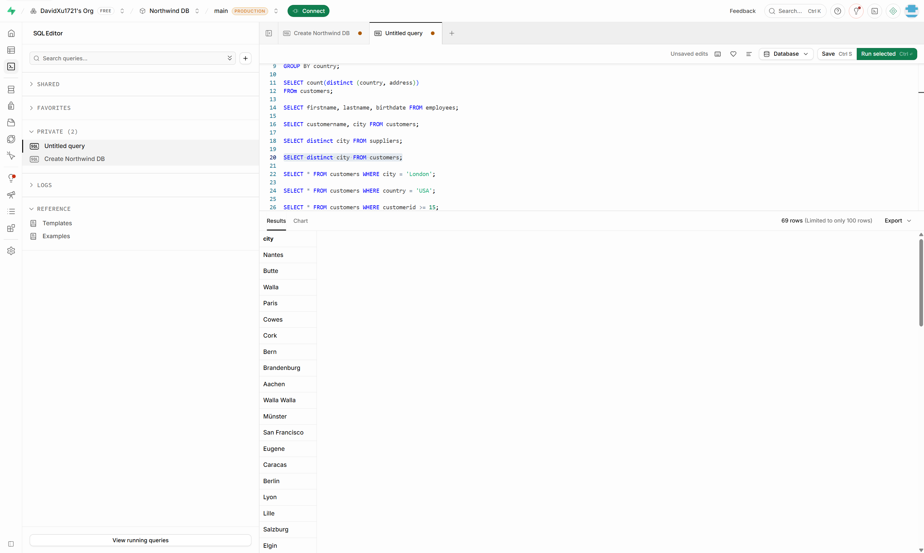

4.📘 High-Value Products Report
The product manager wants to analyse products priced over £50.
➡️ Write a SQL query to retrieve all columns from the Products table where the Price is greater than 50.
SELECT *
FROM products
WHERE price > 50;
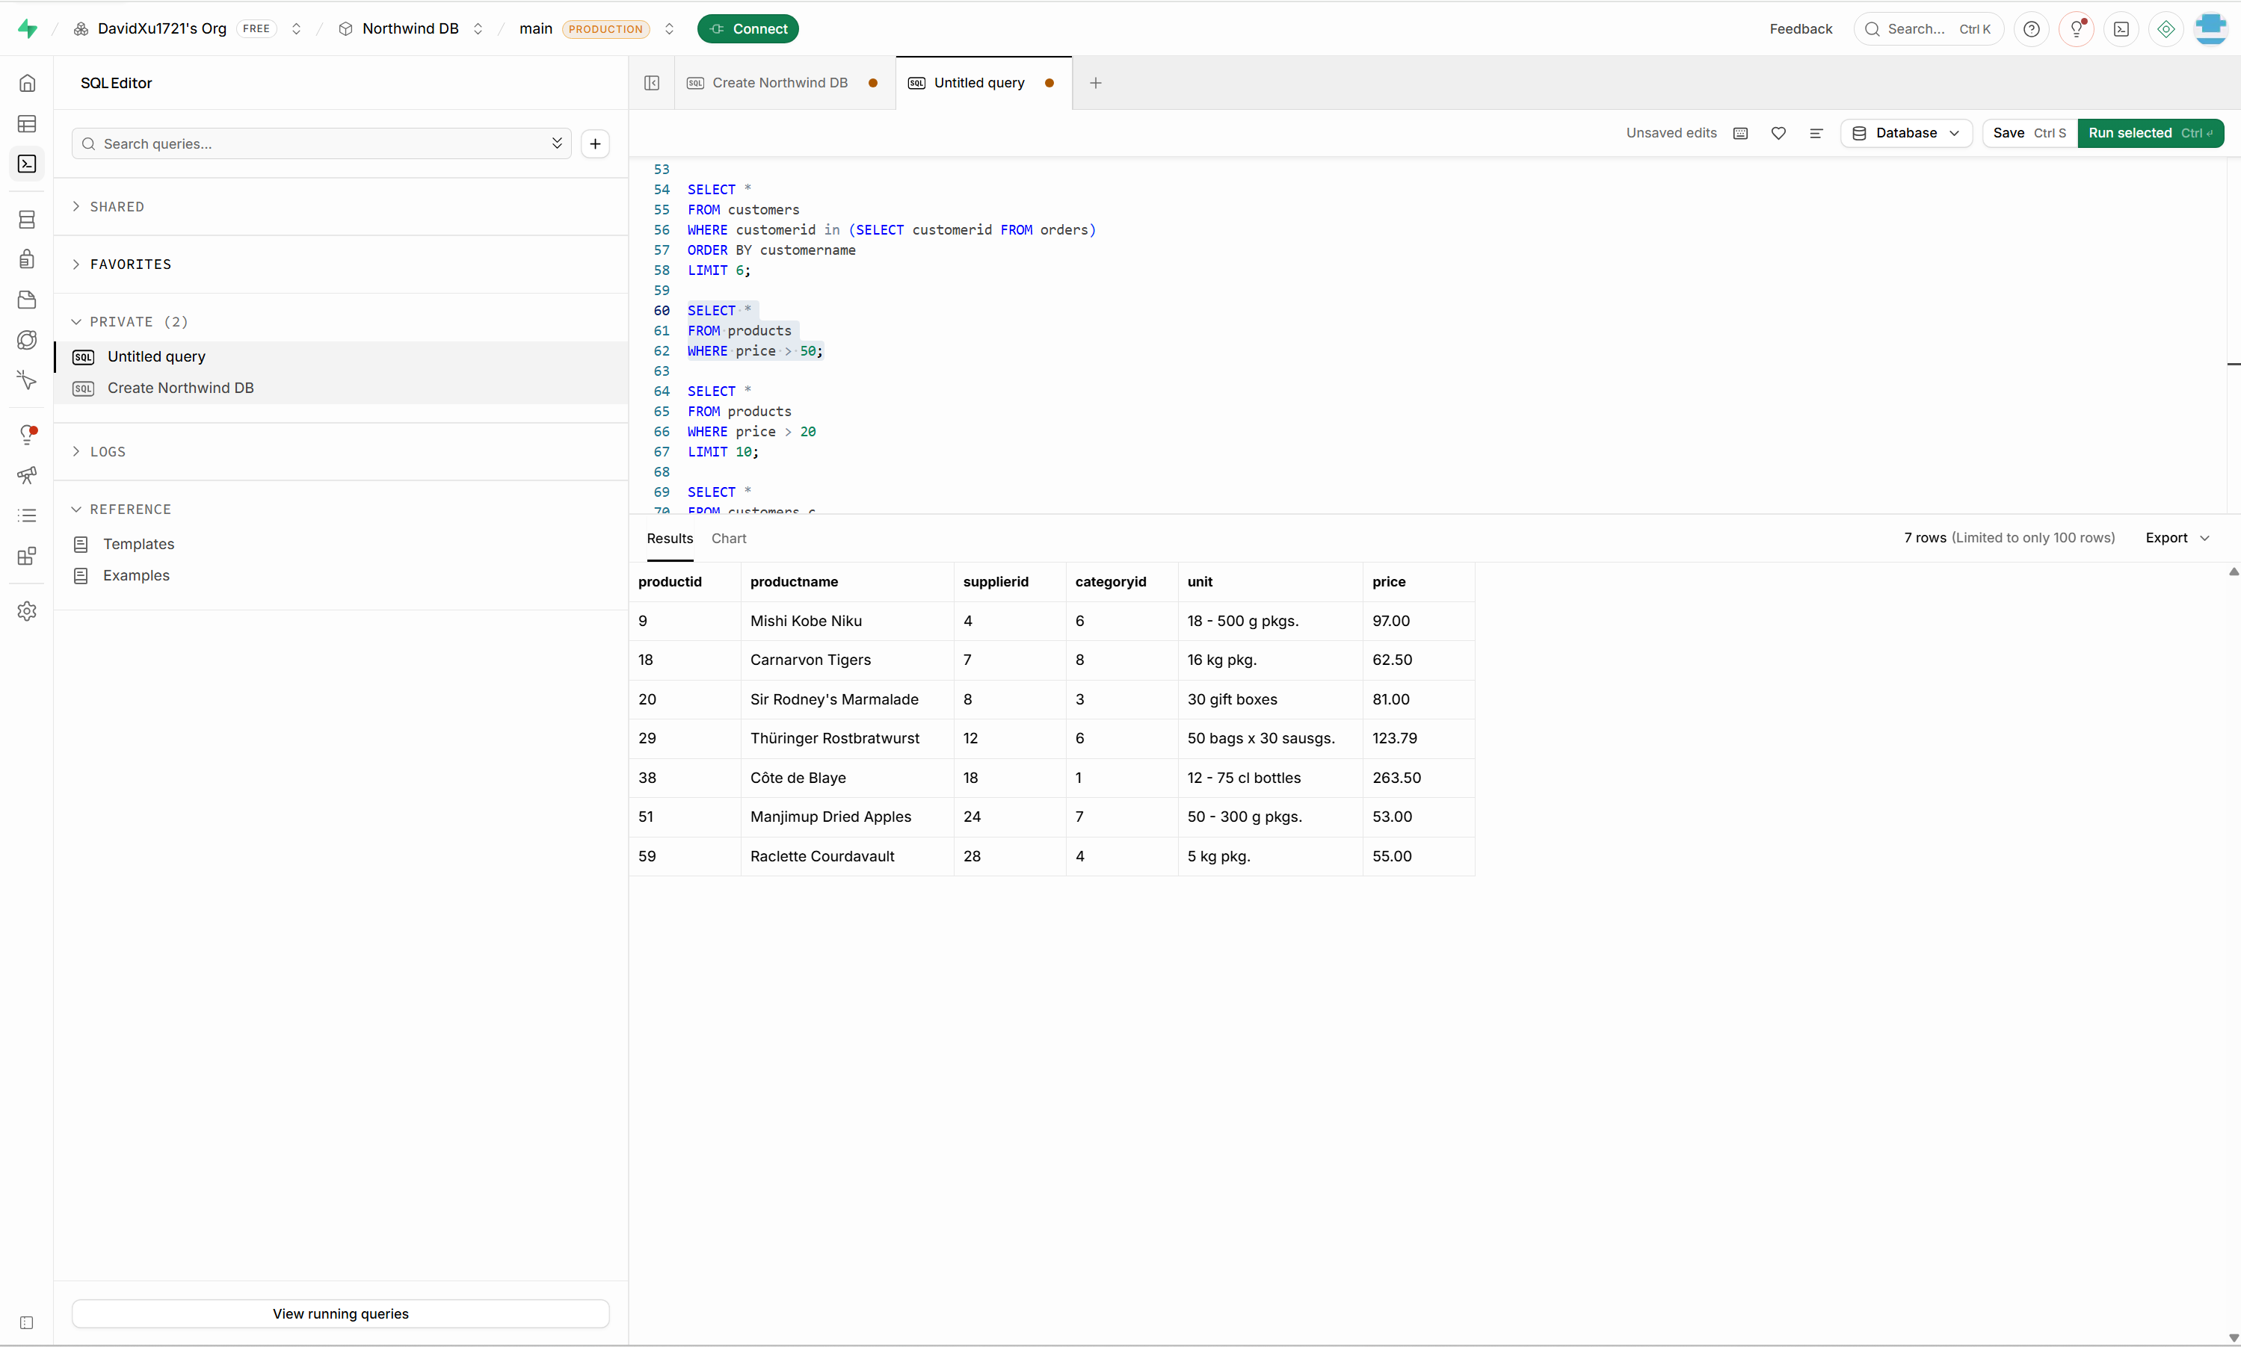

5.📘 International Customers Targeting (USA & UK)
The marketing team is preparing campaigns for customers in the USA and UK.
➡️ Write a SQL query to retrieve all columns from the Customers table where the Country is either 'USA' or 'UK'.
SELECT *
FROM customers
WHERE country IN ('USA', 'UK');

6.📘 Recent Orders Report
Your team needs to analyze the latest orders.
➡️ Write a SQL query to retrieve all columns from the Orders table, sorted by OrderDate in descending order.
SELECT *
FROM orders
ORDER BY orderdate DESC;

7.📘 Mid-Range Products Listing
You are preparing a product list for items priced between £20 and £50.
➡️ Write a SQL query to retrieve all columns from the Products table where the Price is between 20 and 50, ordered by descending Price.
SELECT *
FROM products
WHERE price between 20 and 50
ORDER BY price DESC;

8.📘 Local Marketing in the US (Portland & Kirkland)
You’re focusing on customers from Portland and Kirkland in the USA.
➡️ Write a SQL query to retrieve all columns from the Customers table where the Country is 'USA' and City is either 'Portland' or 'Kirkland', ordered by ascending CustomerName.
SELECT *
FROM customers
WHERE country = 'USA'
AND city IN ('Portland', 'Kirkland')
ORDER BY customername ASC;
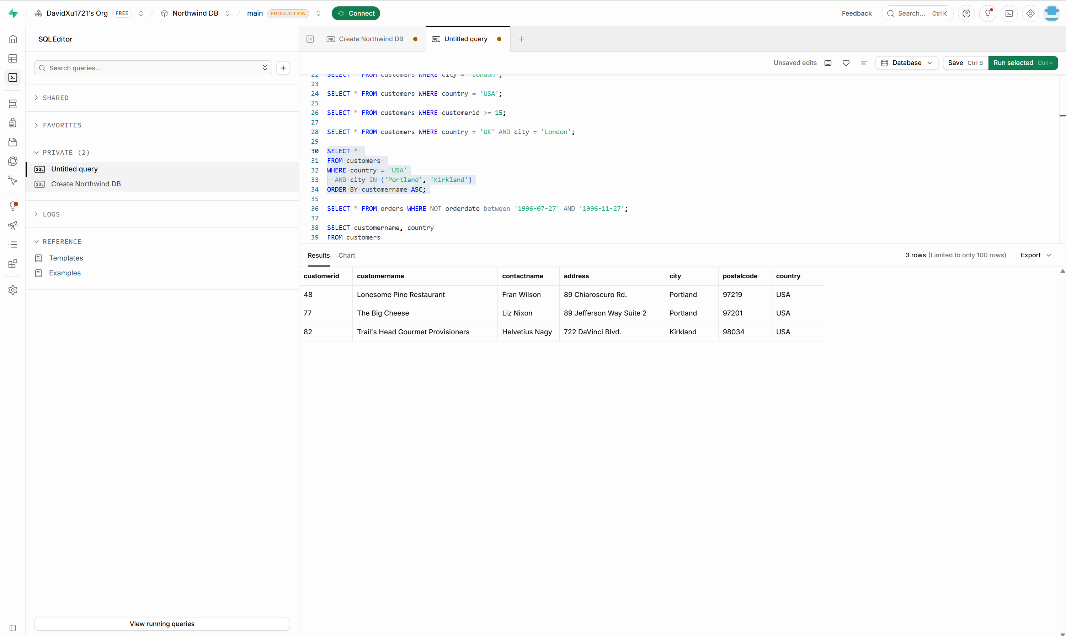

9. 📘 Customers from the UK or London
Prepare a list for promotional emails targeting customers from the UK or those based in London.
➡️ Write a SQL query to retrieve all columns from the Customers table where the Country is 'UK' or City is 'London', ordered by descending CustomerName.
SELECT *
FROM customers
WHERE country = 'UK'
OR city = 'London'
ORDER BY customername DESC;
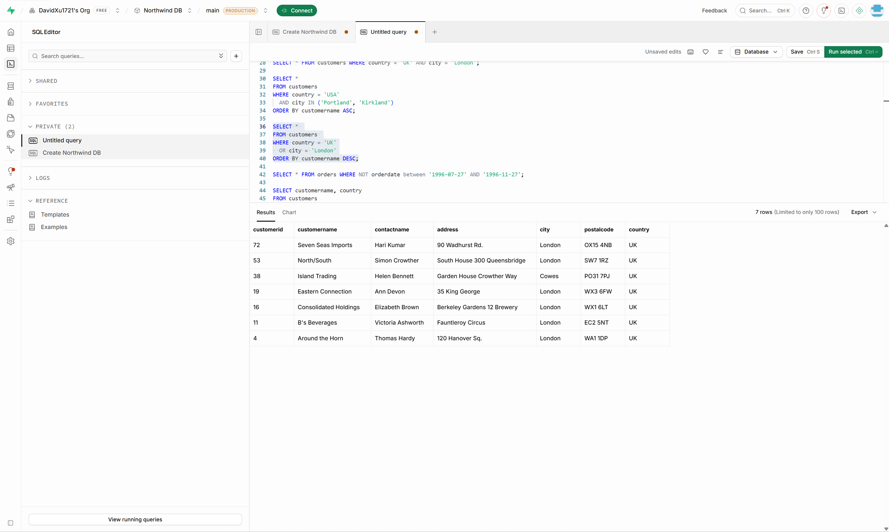

10.📘 Product Inventory for Selected Categories
The inventory team needs products from Category 1 or 2, sorted alphabetically.
➡️ Write a SQL query to retrieve all columns from the Products table where the CategoryID is 1 or 2, ordered by ascending ProductName.
SELECT *
FROM products
WHERE categoryid in (1, 2)
ORDER BY productname ASC;
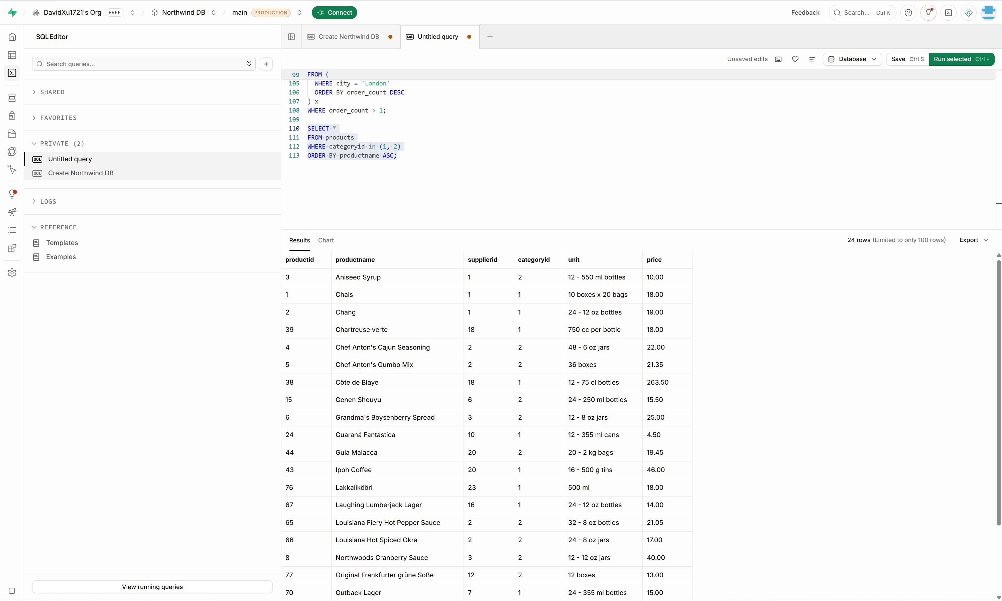

Day 3: Task 1
Scenario-Based Activity: Understanding SQL JOINs
Business Scenario
SkillUp Academy stores its data across several related tables, such as:
- Learners
- Courses
- Trainers
- Enrolments
To create reports (for example, seeing which learners are enrolled on which courses), the data team needs to combine data from multiple tables.
Different types of SQL JOINs are used depending on what information is needed.

Task 1: Explain JOIN Types (Plain English)
For each JOIN type below:
- Explain what the JOIN does in simple terms
- Explain when it would be used in a real scenario
You do not need to write SQL code unless instructed.
JOIN Types to Explain
- Inner Join
- Left Join
- Right Join
- Full Join
- Cross Join
✍️ Use short, clear explanations.
JOIN combines table rows where the specified fields match, it is usually used to link tables with foreign keys to the primary key of other tables to make one big table. The first table specified is considered the left table and the second one is considered the right table, with the result table being displayed as such.

Inner Join excludes any rows that don’t have a matching row on the other table.

Left Join includes all rows on the left table using NULL on the columns of the rows where there is no matching row on the RIGHT table.

Right Join includes all rows on the right table using NULL on the columns of the rows where there is no matching row on the LEFT table
Full Join includes all rows of both tables, using NULL on any columns without matches.

Cross Join takes the product of both tables, matching every row of the left table with every row of the right table. The resulting number of rows is the product of the row numbers of the original tables.

Task 2: Match JOINs to Data Scenarios
Below are example reporting needs at SkillUp Academy.
For each one:
- Identify which JOIN type would be most suitable
- Explain why

Example Scenarios
- Viewing only learners who are enrolled on a course
- Listing all courses, including those with no enrolments yet
- Showing all learners and all courses, even if they are not linked
- Creating all possible combinations of learners and courses for planning
- Comparing learners to other learners (e.g. same course, same city)
- Viewing enrolments even if some related data is missing
✍️ Explain your reasoning in plain English.
- I would use an INNER join as that only selects learners that have enrolled on at least one course and excludes courses with no learners.
- RIGHT outer JOIN (learners -> courses), as this includes courses with no learners
- FULL OUTER JOIN, this keeps all rows even if they are not linked.
- CROSS JOIN, this produces every possible combination of rows from both tables
- SELF (LEFT) JOIN, making sure the id’s don’t match + any other conditions. This is because we are joining the same table, and LEFT join allows us to see learners with no relevant learners to compare to
- LEFT JOIN (learners -> courses), this shows learners even if the courseId is missing

Day 3: Task 2
You are a junior data analyst at Northwind Traders. Your manager has assigned you a series of real-world business tasks. For each scenario:
- Write an SQL query to solve the request. Write an SQL query to solve the request.
- Run the query in Supabase using the Northwind database.
- Paste your query in the box below each question as evidence of completion.

1.📘 Linking Products to Suppliers
Management wants to know which supplier provides each product in the inventory.
➡️ Write a SQL query to find the supplier of each product.
SELECT p.productname, s.suppliername
FROM products p
LEFT JOIN suppliers s
ON p.supplierid = s.supplierid;
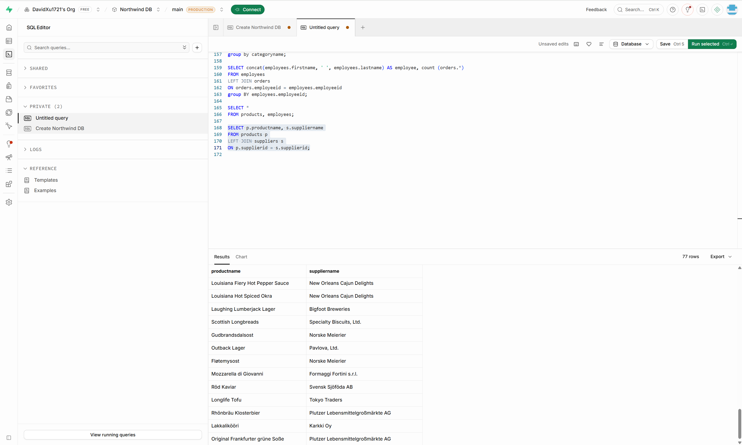

2. 📘 Classifying Products by Category
The category manager is reviewing how products are organized.
➡️ Write a SQL query to find the category of each product.
SELECT p.productname, c.categoryname
FROM products p
LEFT JOIN categories c
ON p.categoryid = c.categoryid;
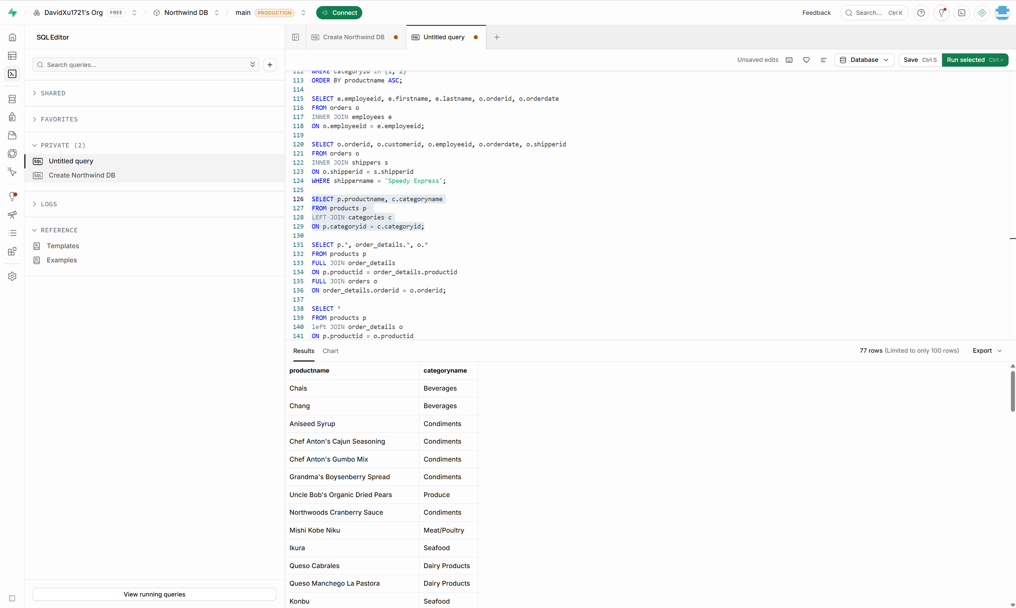

3.📘 Category-Specific Product Report: Meat/Poultry
The food department wants to view all items in the Meat/Poultry category.
➡️ Write a SQL query to retrieve all products belonging to the Meat/Poultry category.
SELECT p.productname, c.categoryname
FROM products p
LEFT JOIN categories c
ON p.categoryid = c.categoryid
WHERE c.categoryname = 'Meat/Poultry';
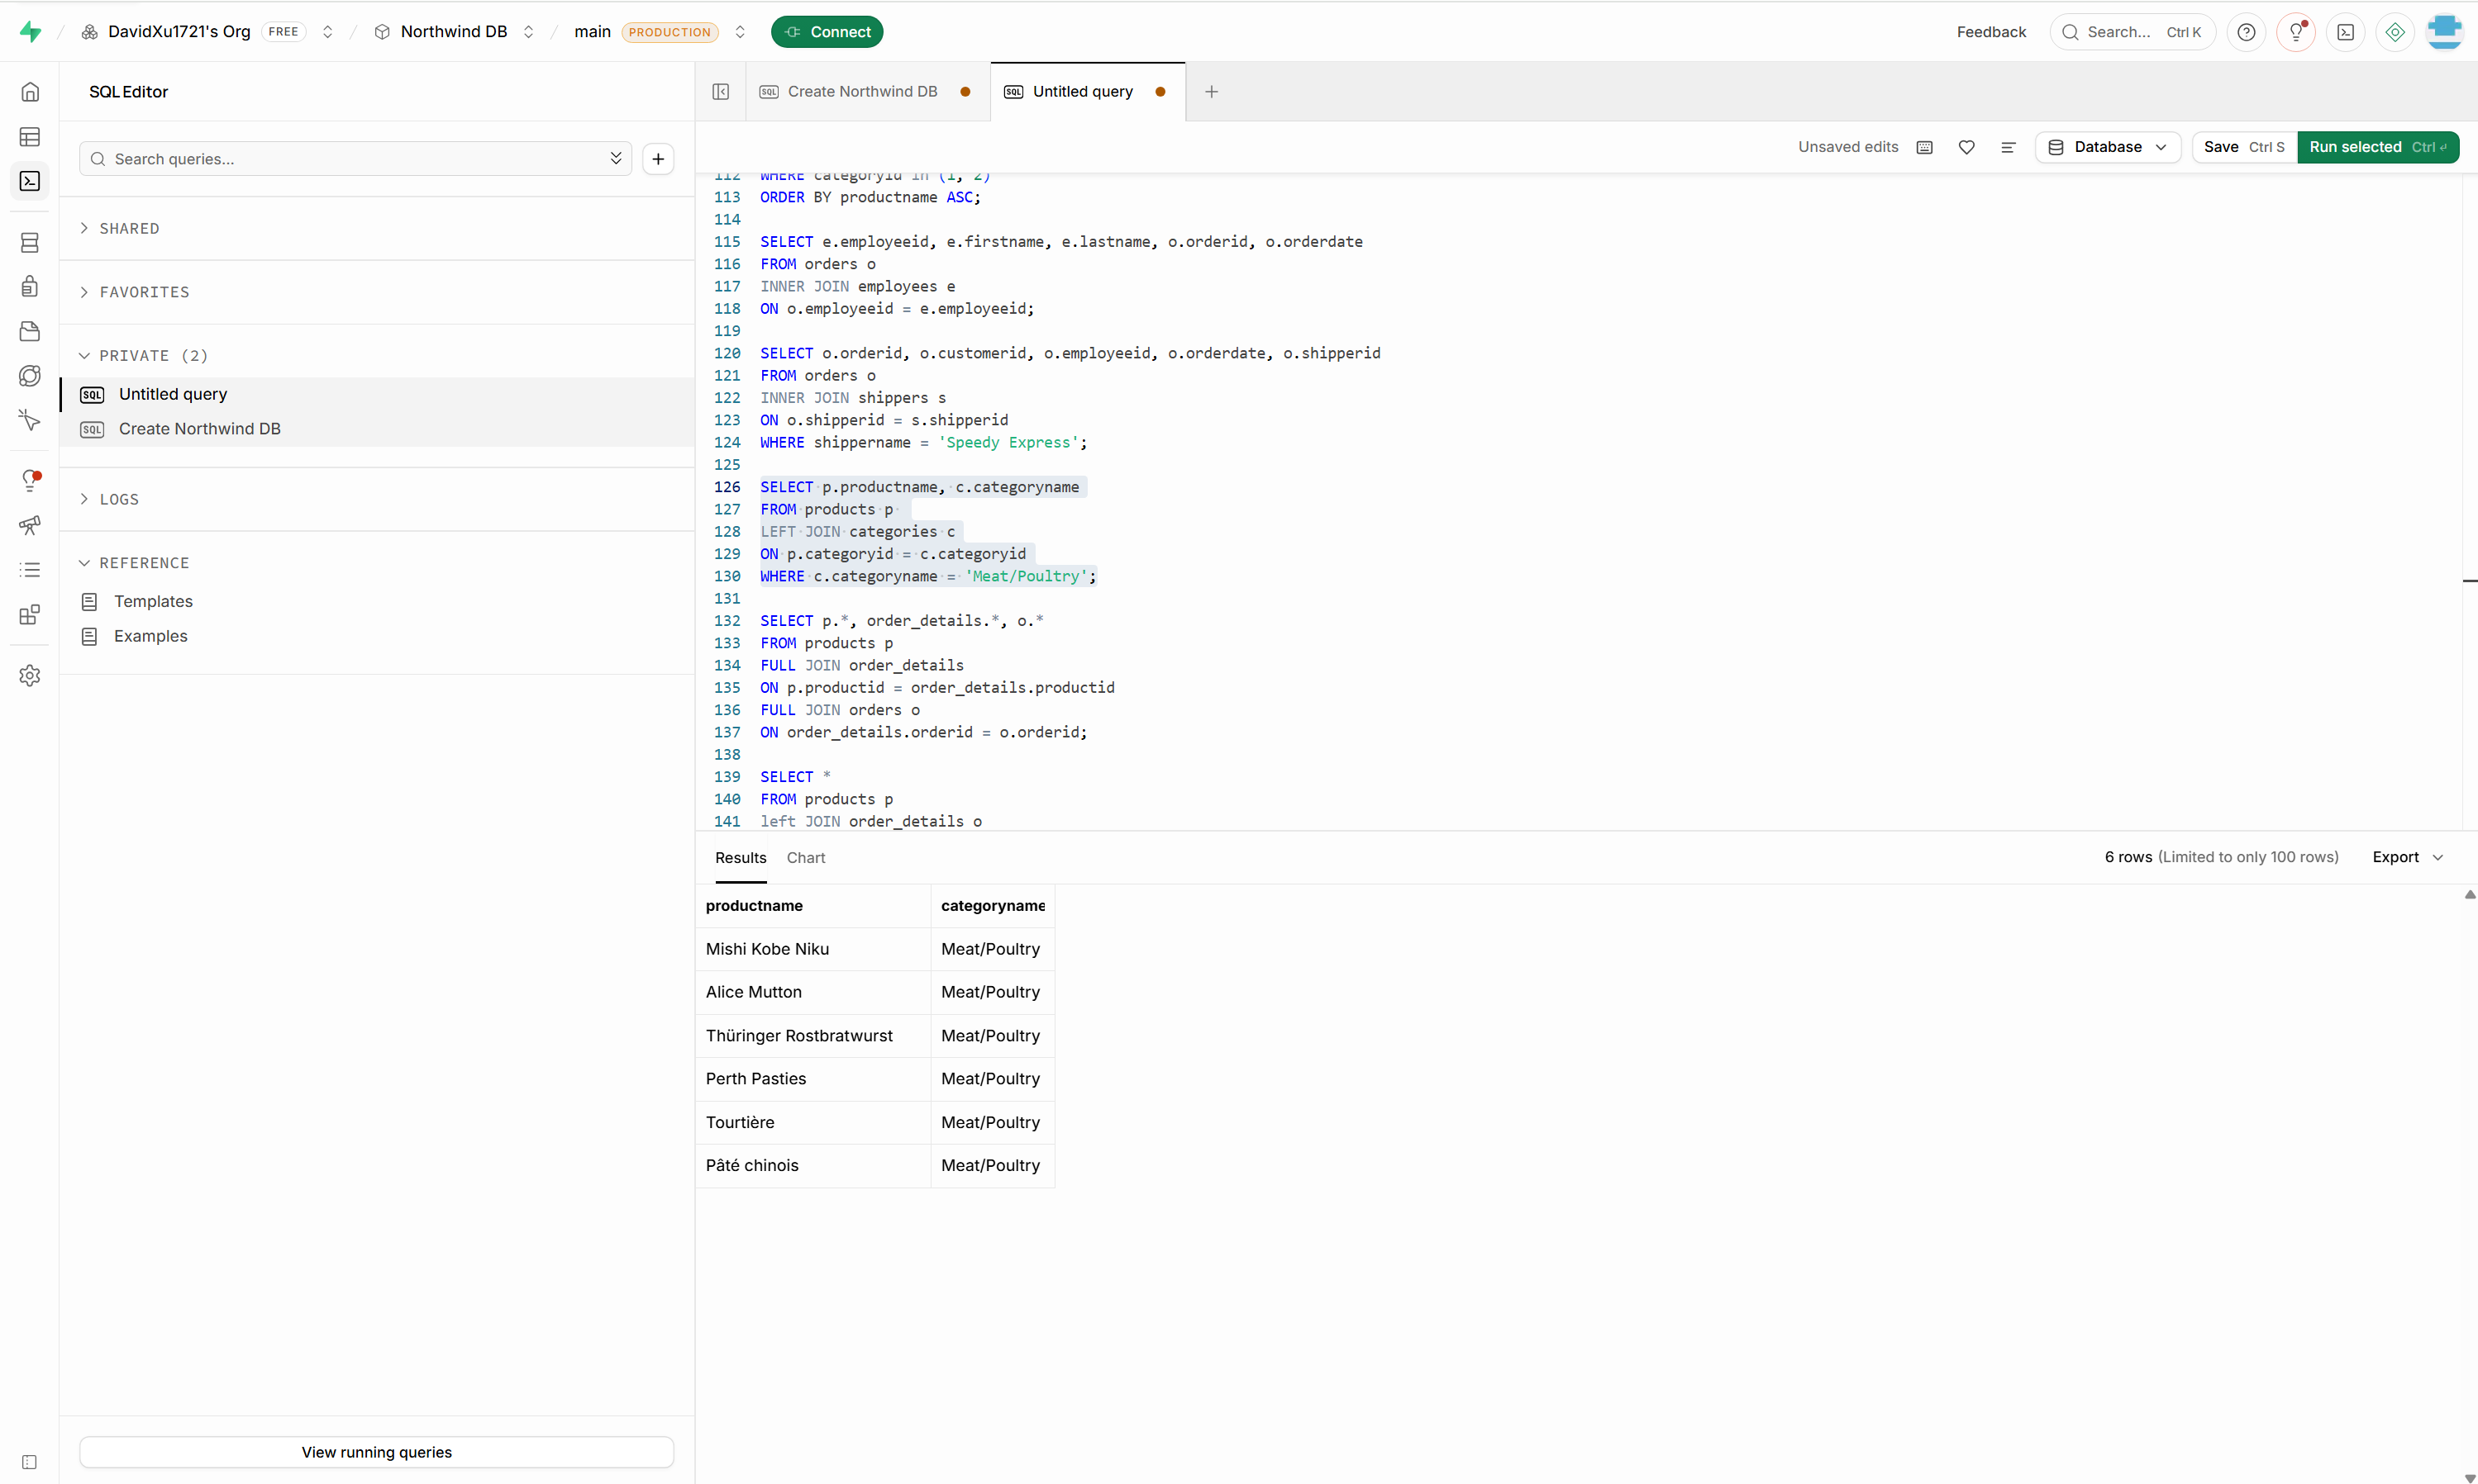

4.📘 Complete Order Overview
The business team wants to see a detailed order list with customer and employee information.
➡️ Write a SQL query to retrieve the Order ID, Order Date, Customer Name, and Employee Name for all orders.
SELECT o.orderid, o.orderdate, c.customername, concat(e.firstname, ' ', e.lastname) as employeename
FROM orders o
LEFT JOIN customers c
ON o.customerid = c.customerid
LEFT JOIN employees e
ON o.employeeid = e.employeeid;
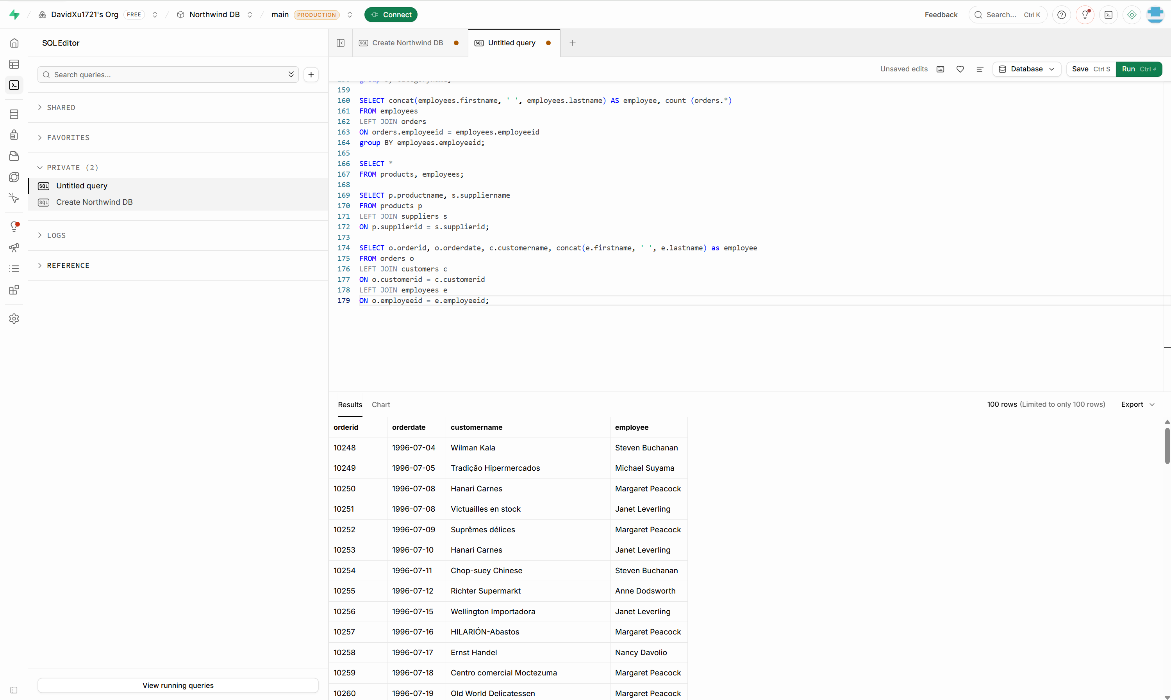

5.📘 Supply Chain Overview Report
Your manager wants to see the product name, its category, and the name of its supplier all in one report.
➡️ Write a SQL query to retrieve the Product Name, Category Name, and Supplier Name for all products.
SELECT p.productname, c.categoryname, s.suppliername
FROM products p
LEFT JOIN categories c
ON p.categoryid = c.categoryid
LEFT JOIN suppliers s
ON p.supplierid = s.supplierid;
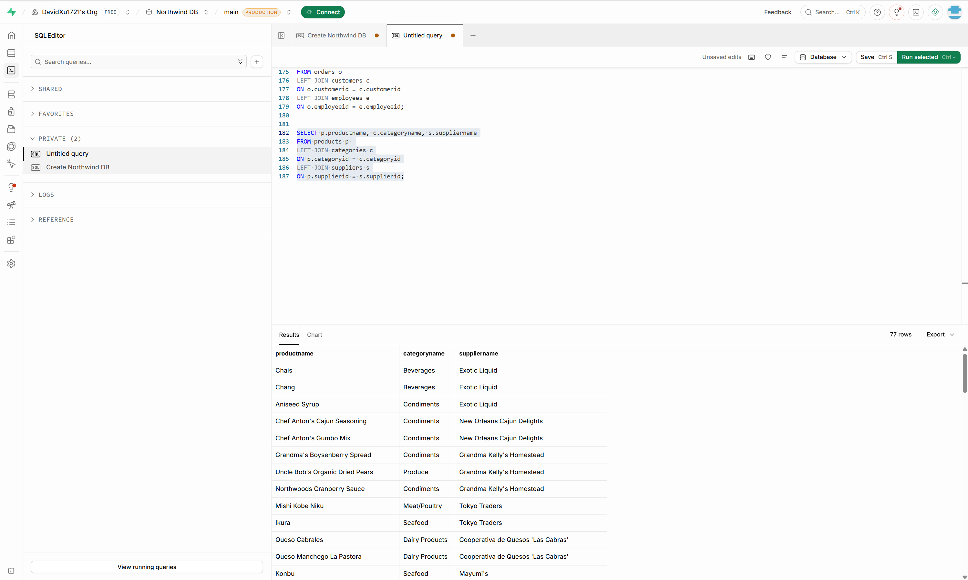

6.📘 Yearly Order Summary – 1996
The team is auditing customer orders made in 1996.
➡️ Write a SQL query to create a report for all the orders of 1996 and their customers.
SELECT o.*, c.*
FROM orders o
LEFT JOIN customers c
ON o.customerid = c.customerid
WHERE o.orderdate BETWEEN '1996-01-01' AND '1996-12-31'
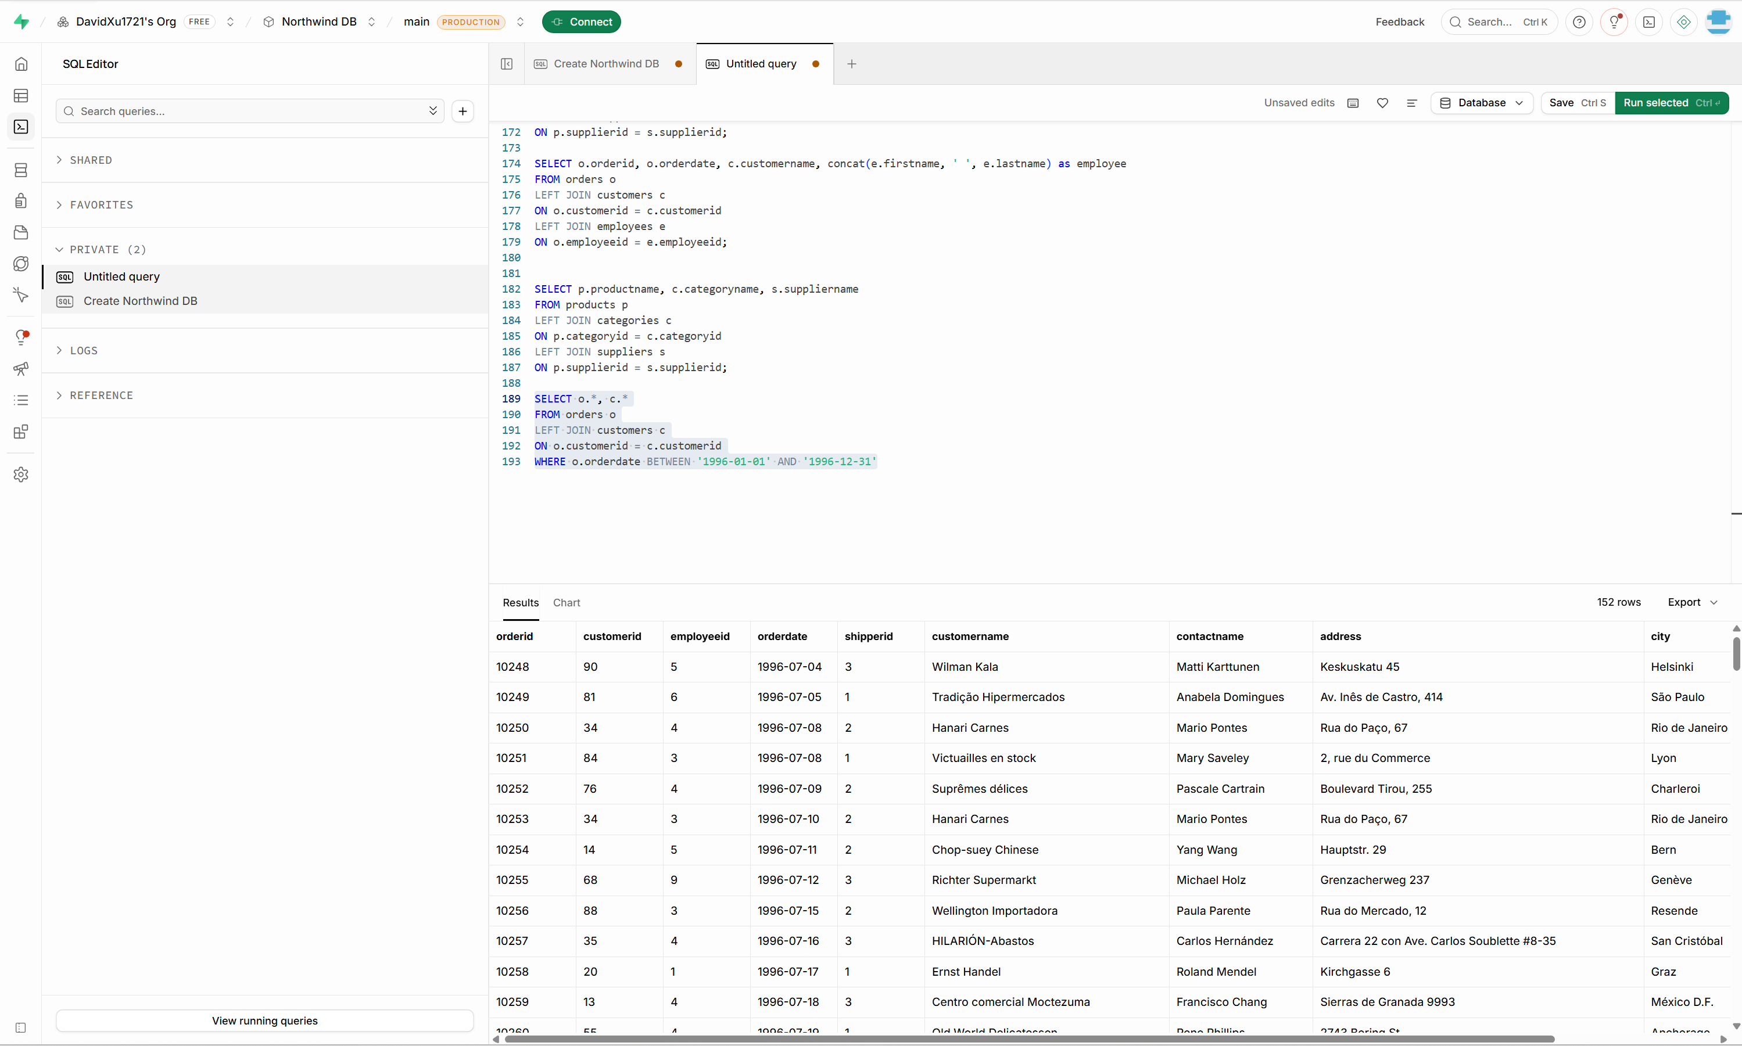

7.📘 Product Count by Category
The product team wants to know how many products exist under each category.
➡️ Write a SQL query to retrieve all categories along with the number of products in each category.
SELECT categoryname, count(*) as num_of_products
FROM categories
LEFT JOIN products
ON categories.categoryid = products.categoryid
GROUP by categoryname;
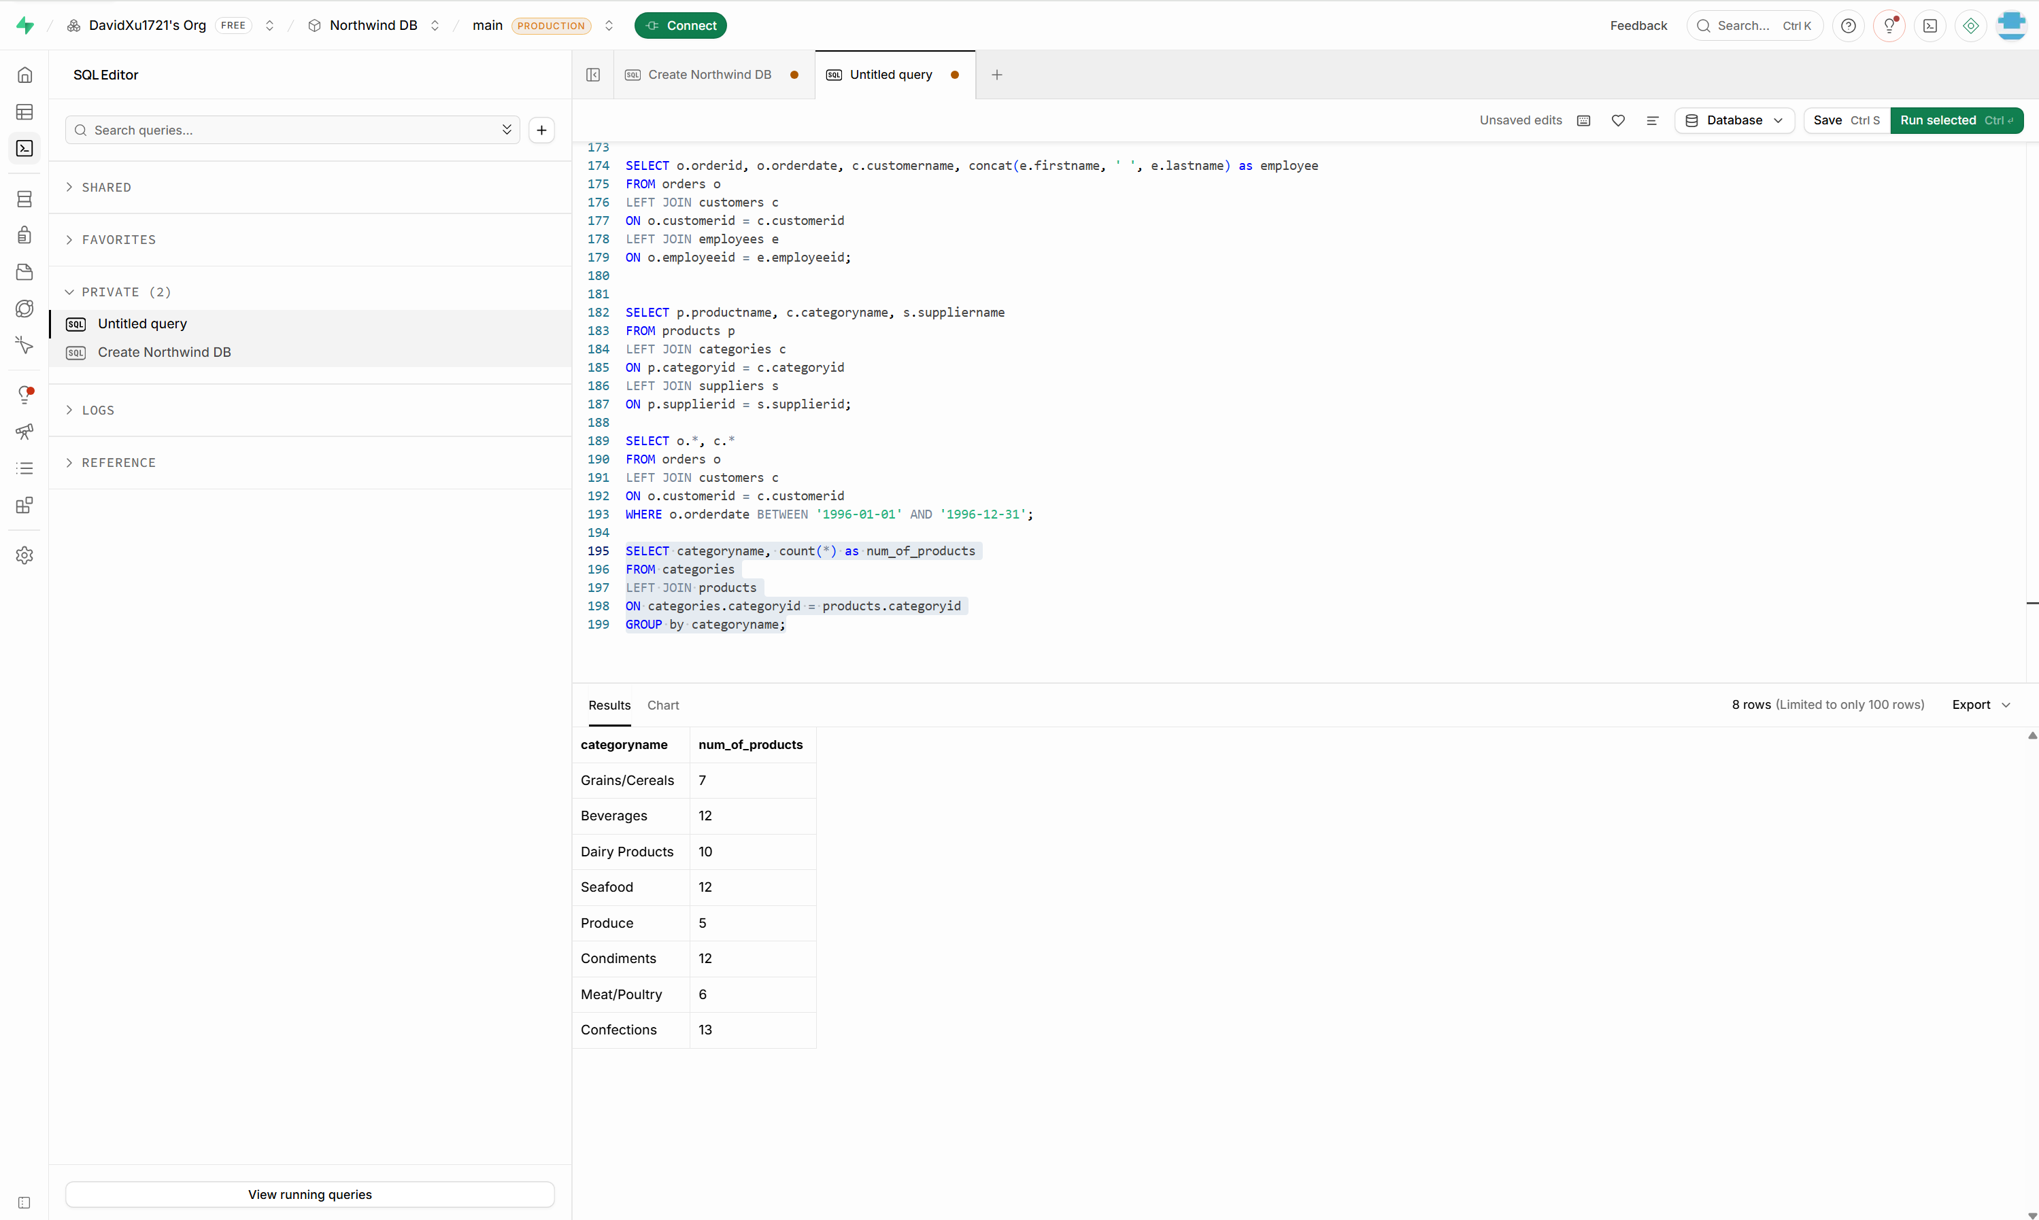

8.📘 Sales Volume Breakdown
The sales department wants to analyze how much of each product was ordered and at what price.
➡️ Write a SQL query to retrieve all products with their prices and the quantity ordered for each product.
SELECT productname, price, sum(o.quantity) as Total_quantity_ordered
FROM products p
LEFT JOIN order_details o
ON p.productid = o.productid
GROUP BY productname, price;
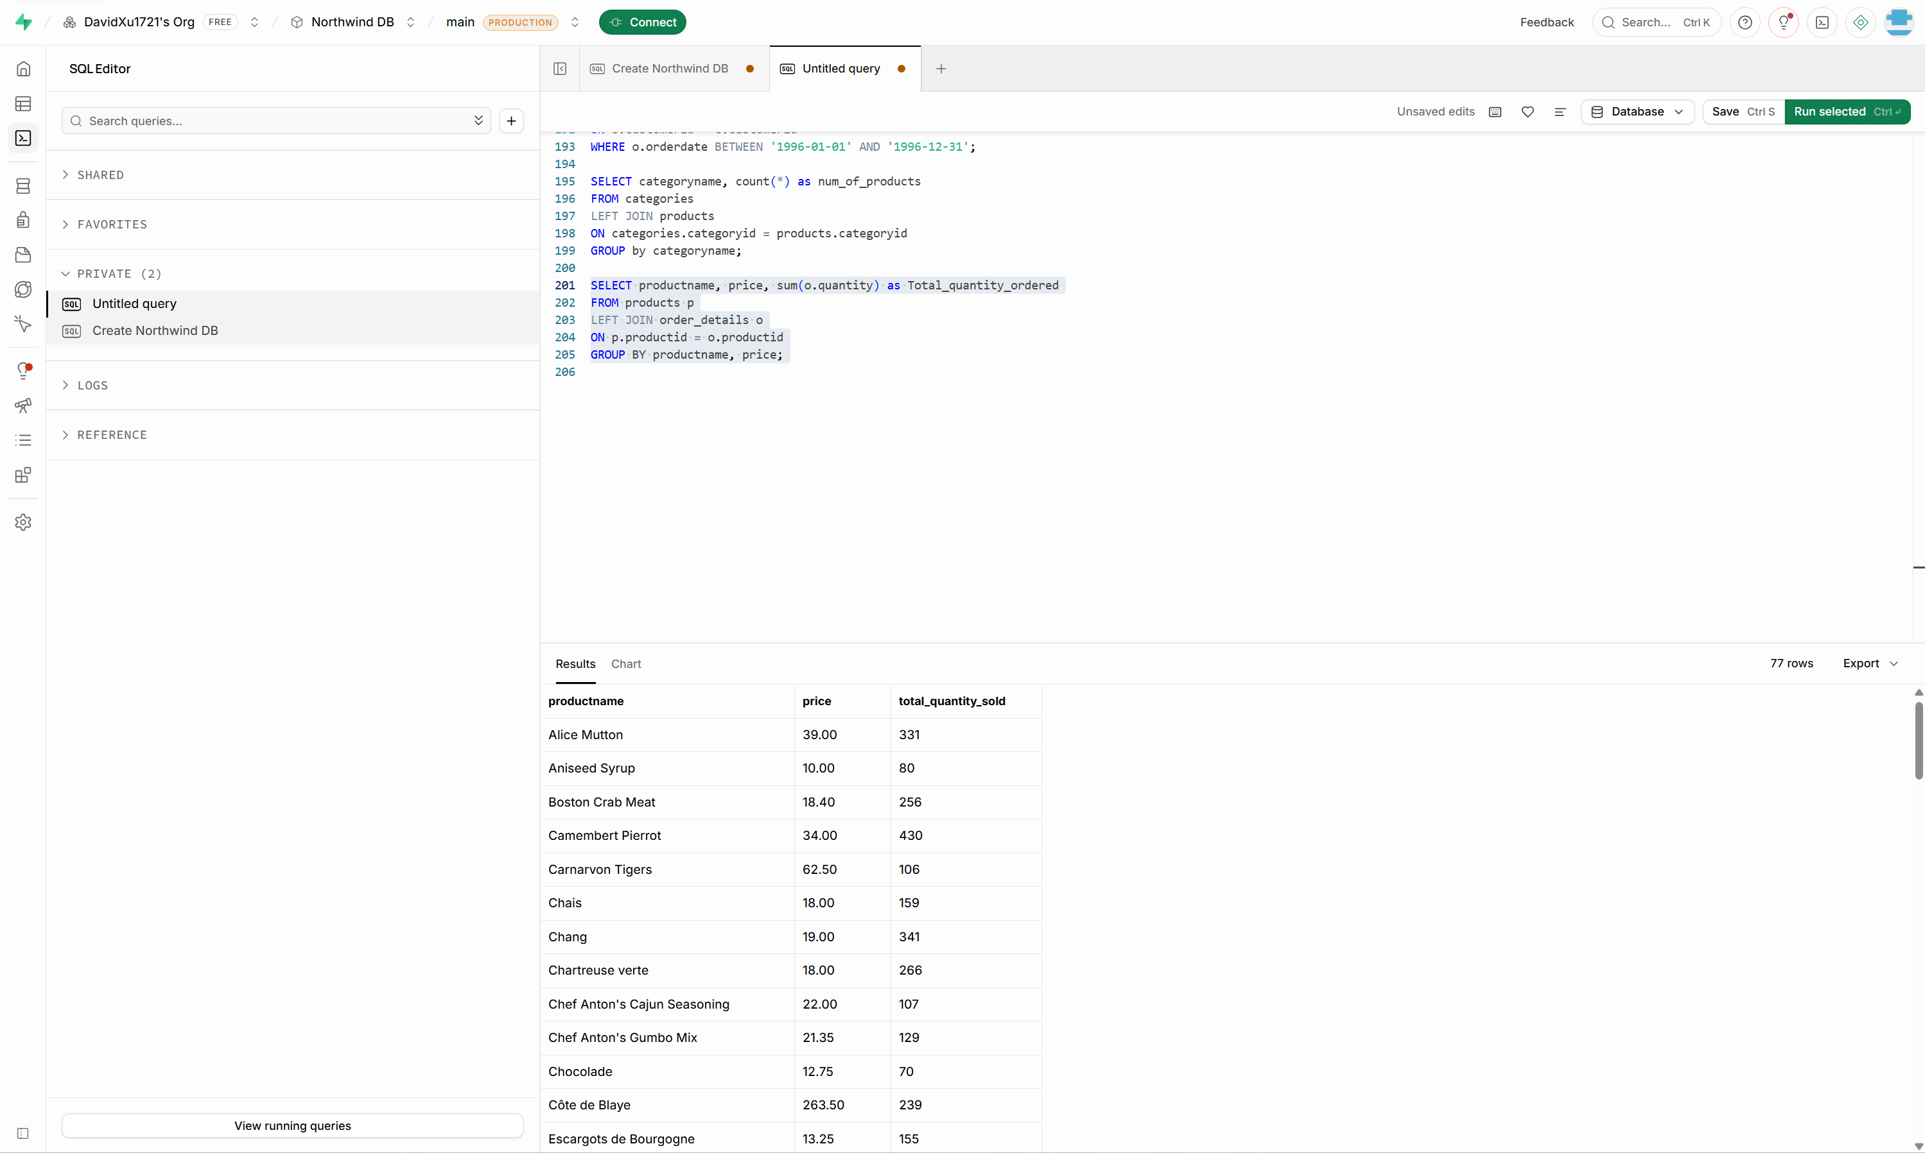

Day 4: Task 1: SQL Practical

You are working as a junior data analyst for an international research organization analysing countries, cities, and languages from around the world. Your job is to write and run SQL queries that provide useful global insights.
Setting up the database:

- Visit your Superbase profile
- Create a new project
- Open and copy SQL script here Create World DB on Supabase
- Go to SQL Editor and paste it on new query window.
- Go to Table editor and verify city, country and countrylanguage tables are created.
- You can also watch this video to create it. How to create World DB on Supabase.webm

- Count Cities in USA: Scenario: You've been tasked with conducting a demographic analysis of cities in the United States. Your first step is to determine the total number of cities within the country to provide a baseline for further analysis.

-- Count Cities in USA
SELECT count(*) AS num_of_cities_in_united_states
FROM city
JOIN country
ON city.countrycode = country.code;
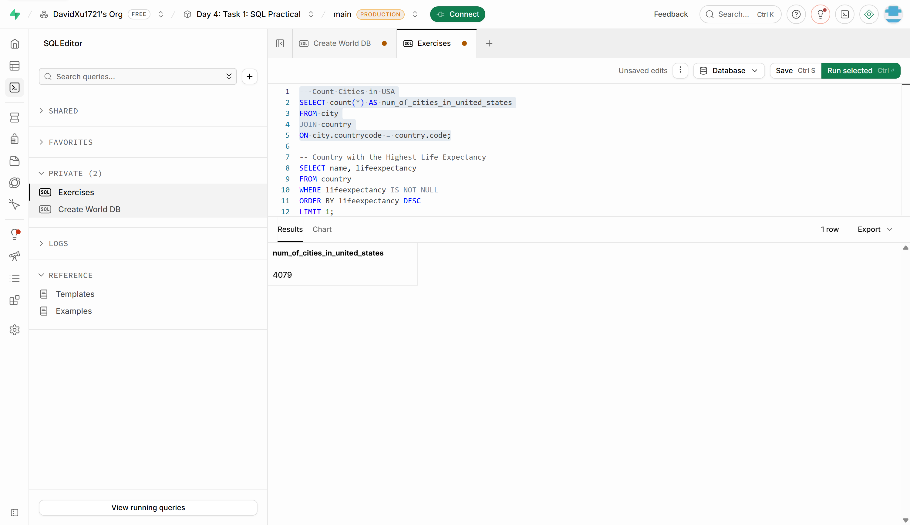

- Country with Highest Life Expectancy: Scenario: As part of a global health initiative, you've been assigned to identify the country with the highest life expectancy. This information will be crucial for prioritising healthcare resources and interventions.

-- Country with the Highest Life Expectancy
SELECT name, lifeexpectancy
FROM country
WHERE lifeexpectancy IS NOT NULL
ORDER BY lifeexpectancy DESC
LIMIT 1;
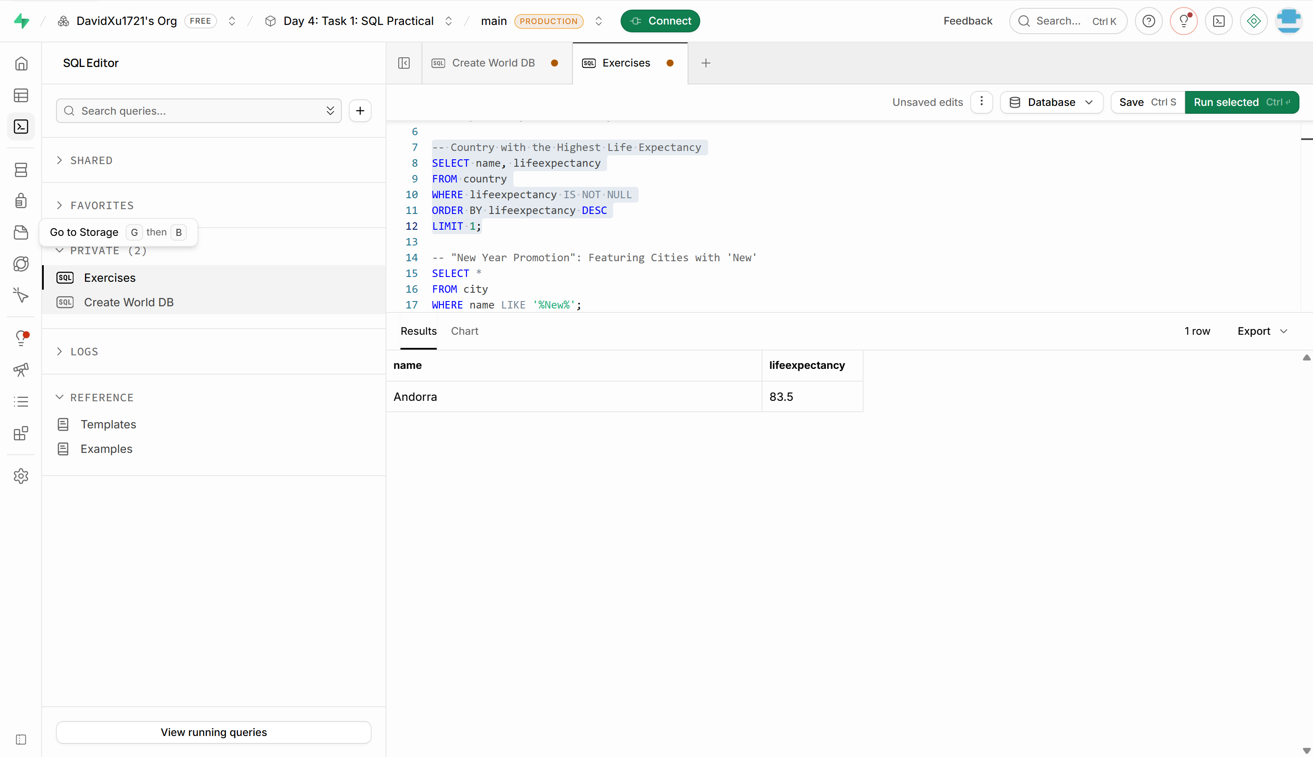

- "New Year Promotion": Featuring Cities with 'New' : Scenario: In anticipation of the upcoming New Year, your travel agency is gearing up for a special promotion featuring cities with names including the word 'New'. You're tasked with swiftly compiling a list of all cities from around the world. This curated selection will be essential in creating promotional materials and enticing travellers with exciting destinations to kick off the New Year in style.
-- "New Year Promotion": Featuring Cities with 'New'
SELECT *
FROM city
WHERE name LIKE '%New%';
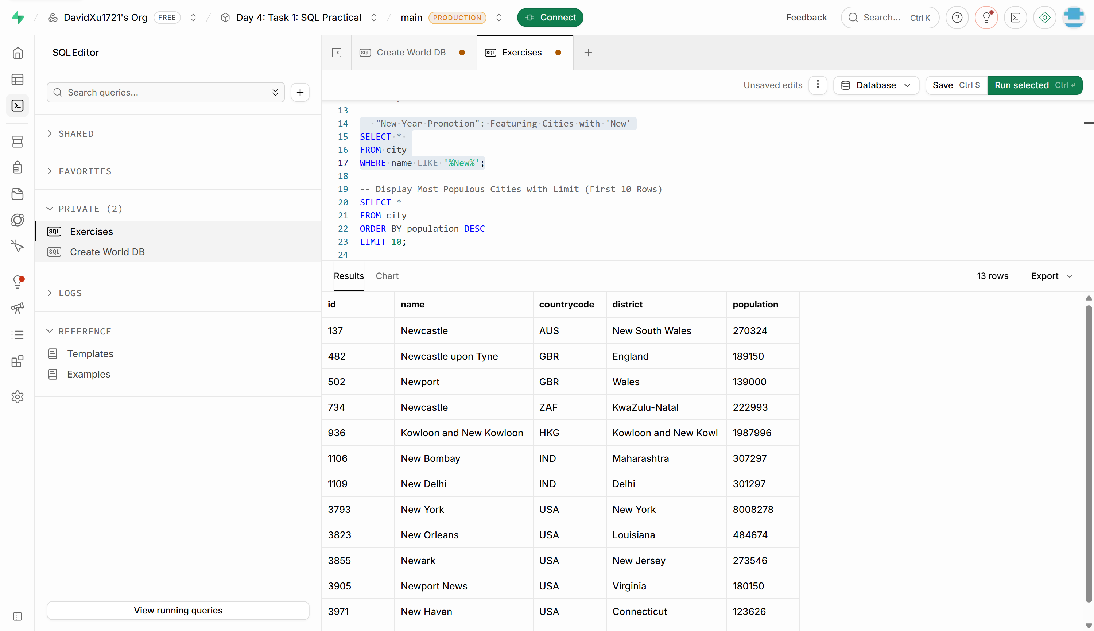

- Display Columns with Limit (First 10 Rows): Scenario: You're tasked with providing a brief overview of the most populous cities in the world. To keep the report concise, you're instructed to list only the first 10 cities by population from the database.
-- Display Most Populous Cities with Limit (First 10 Rows)
SELECT *
FROM city
ORDER BY population DESC
LIMIT 10;
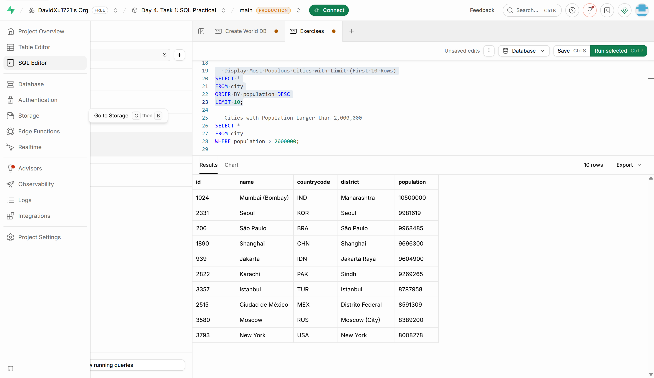

- Cities with Population Larger than 2,000,000: Scenario: A real estate developer is interested in cities with substantial population sizes for potential investment opportunities. You're tasked with identifying cities from the database with populations exceeding 2 million to focus their research efforts.

-- Cities with Population Larger than 2,000,000
SELECT *
FROM city
WHERE population > 2000000;
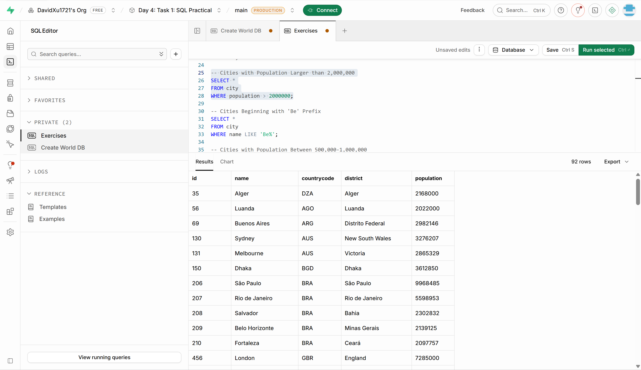

- Cities Beginning with 'Be' Prefix: Scenario: A travel blogger is planning a series of articles featuring cities with unique names. You're tasked with compiling a list of cities from the database that start with the prefix 'Be' to assist in the blogger's content creation process.
-- Cities Beginning with 'Be' Prefix
SELECT *
FROM city
WHERE name LIKE 'Be%';
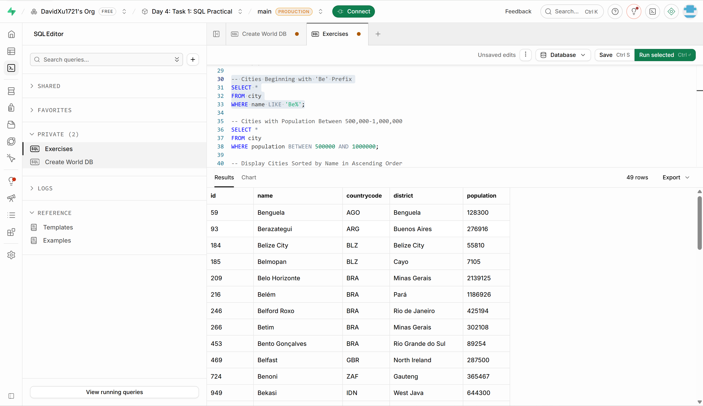

- Cities with Population Between 500,000-1,000,000: Scenario: An urban planning committee needs to identify mid-sized cities suitable for infrastructure development projects. You're tasked with identifying cities with populations ranging between 500,000 and 1 million to inform their decision-making process.
-- Cities with Population Between 500,000-1,000,000
SELECT *
FROM city
WHERE population BETWEEN 500000 AND 1000000;
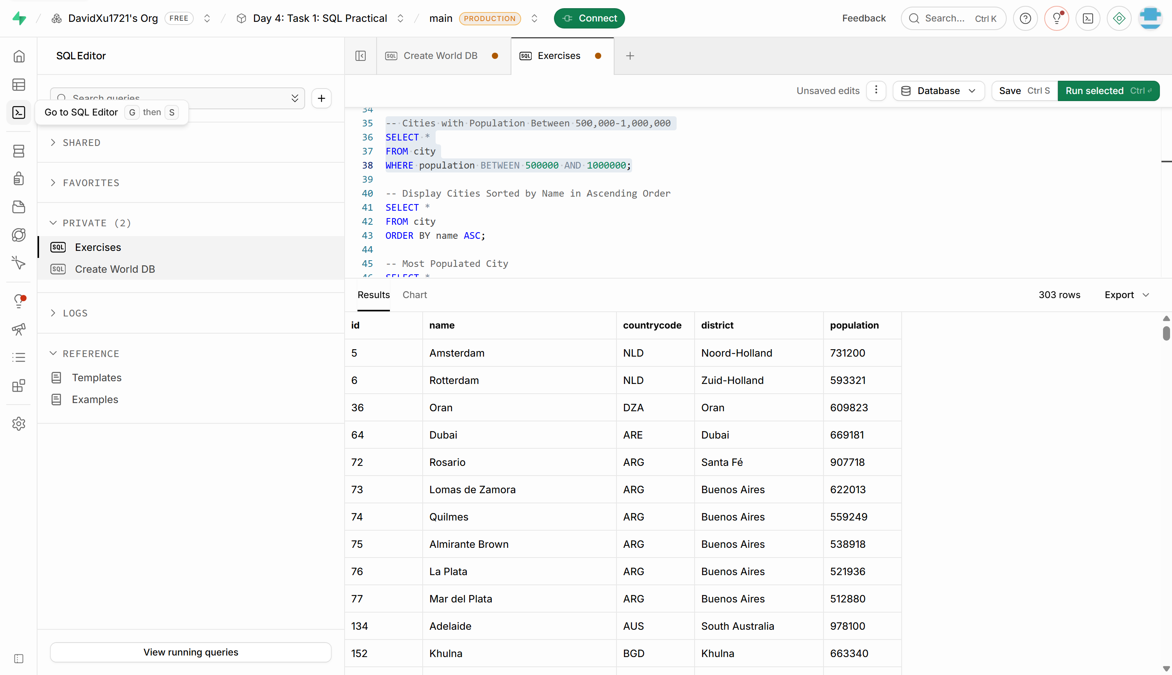

- Display Cities Sorted by Name in Ascending Order: Scenario: A geography teacher is preparing a lesson on alphabetical order using city names. You're tasked with providing a sorted list of cities from the database in ascending order by name to support the lesson plan.
-- Display Cities Sorted by Name in Ascending Order
SELECT *
FROM city
ORDER BY name ASC;
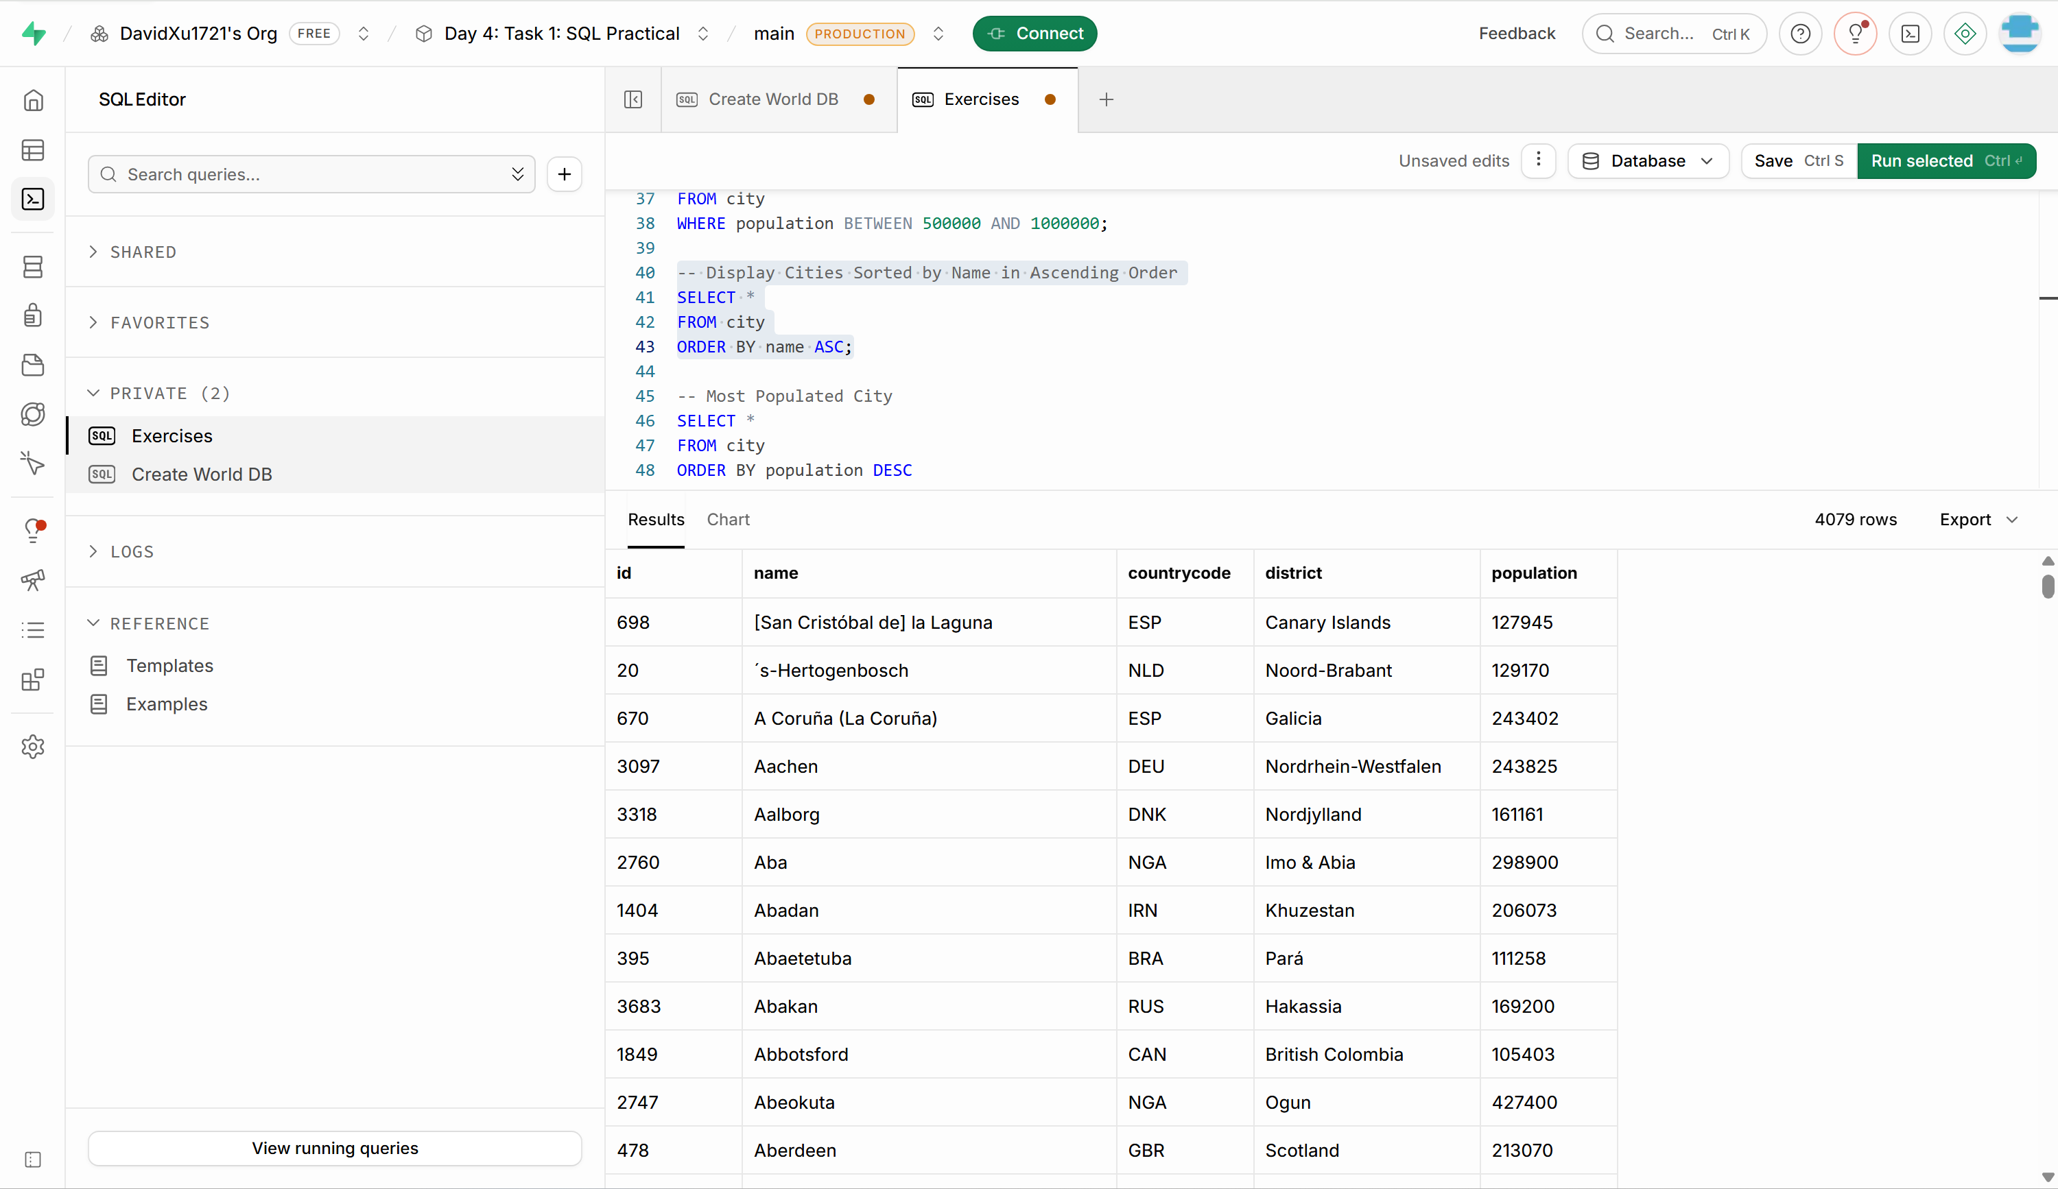

- Most Populated City: Scenario: A real estate investment firm is interested in cities with significant population densities for potential development projects. You're tasked with identifying the most populated city from the database to guide their investment decisions and strategic planning.
-- Most Populated City
SELECT *
FROM city
ORDER BY population DESC
LIMIT 1;
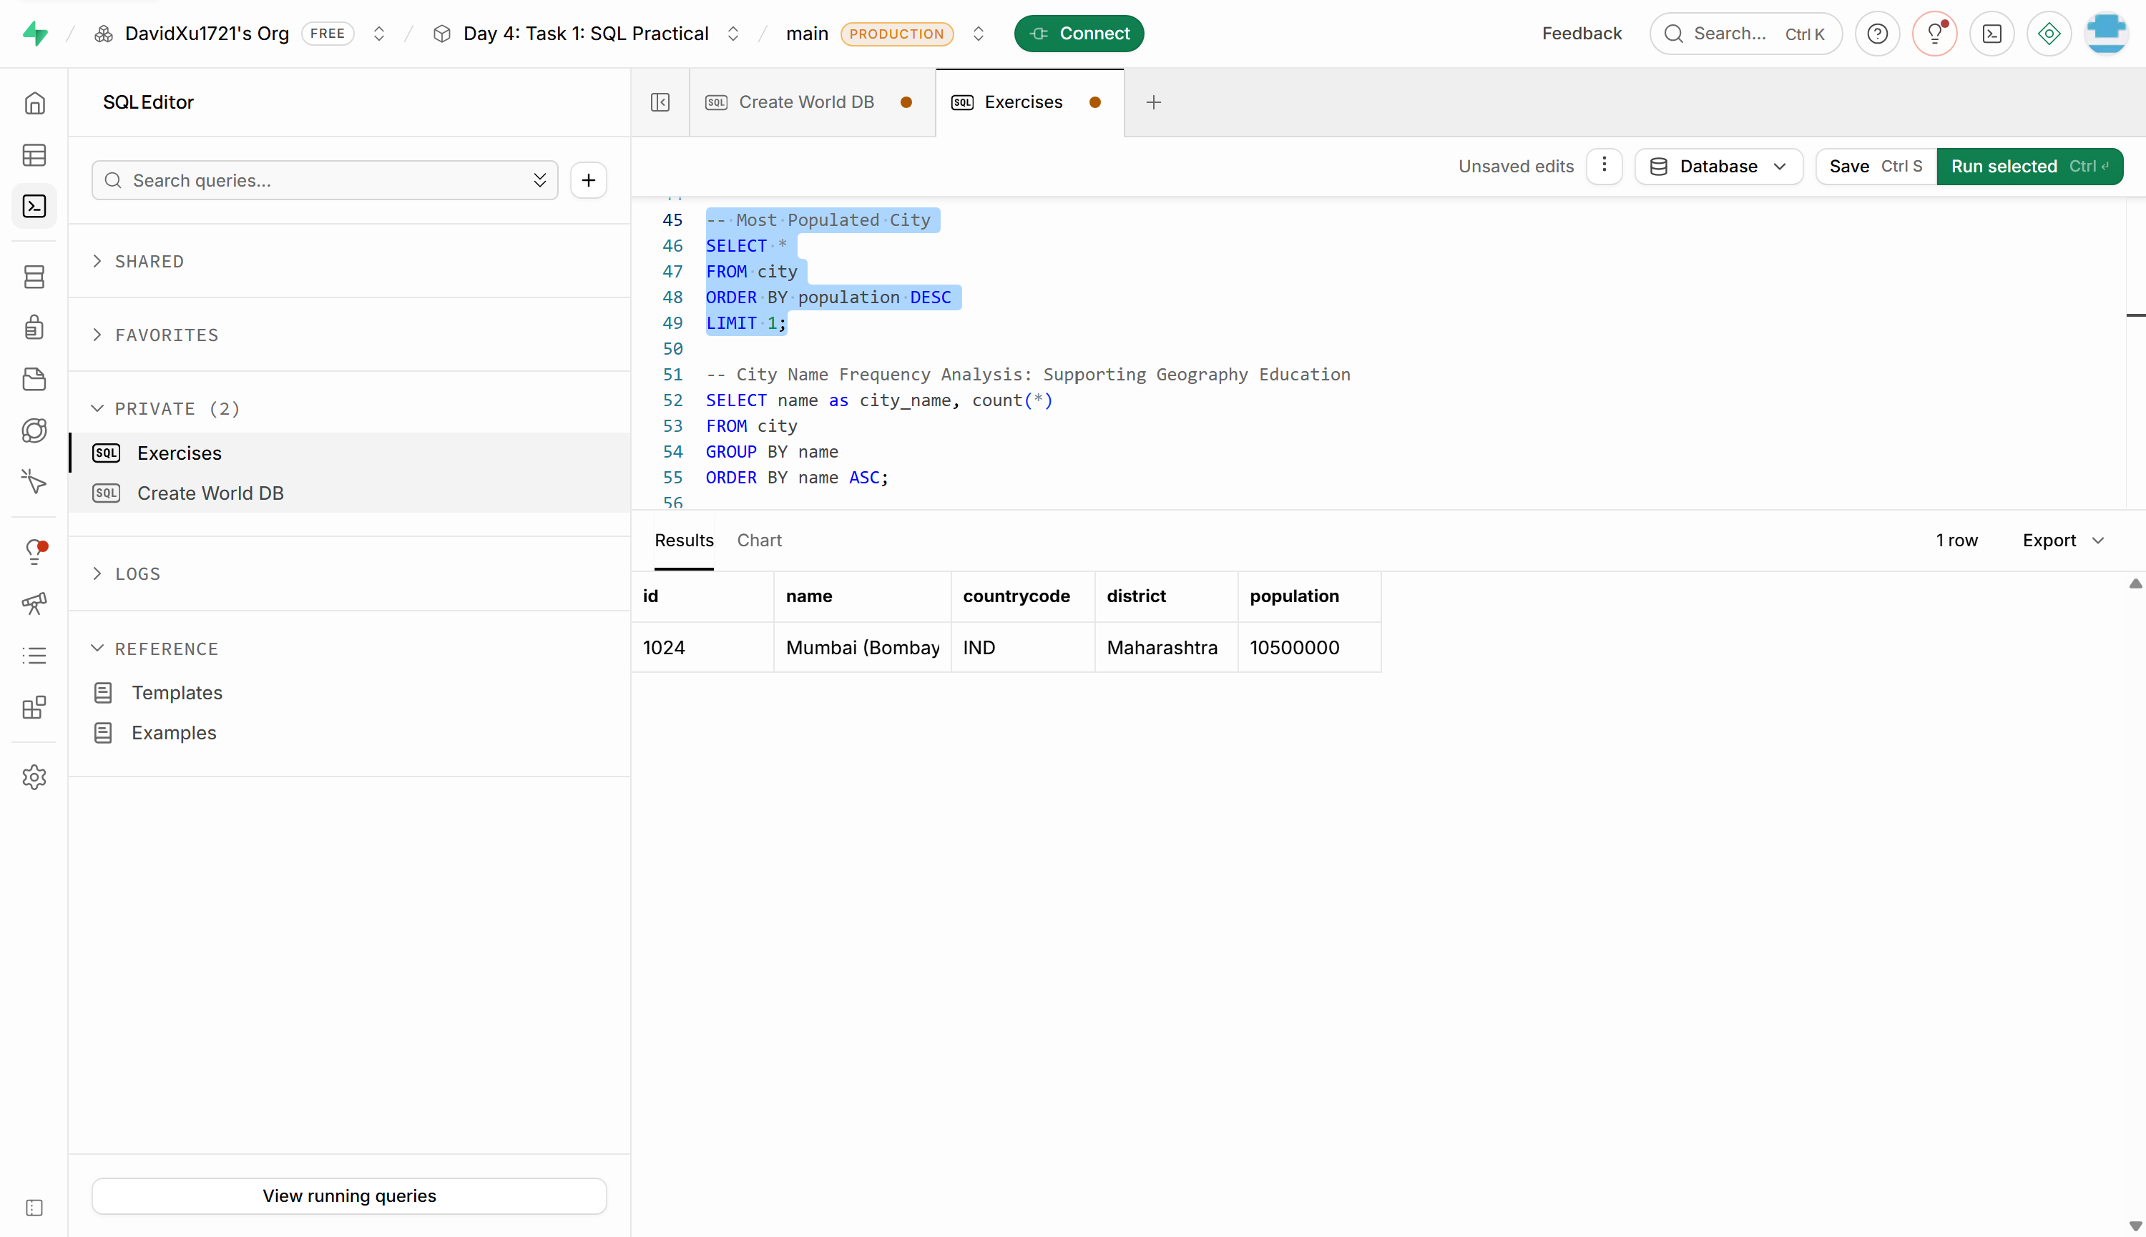

- City Name Frequency Analysis: Supporting Geography Education Scenario: In a geography class, students are learning about the distribution of city names around the world. The teacher, in preparation for a lesson on city name frequencies, wants to provide students with a list of unique city names sorted alphabetically, along with their respective counts of occurrences in the database. You're tasked with this sorted list to support the geography teacher.
-- City Name Frequency Analysis: Supporting Geography Education
SELECT name as city_name, count(*)
FROM city
GROUP BY name
ORDER BY name ASC;
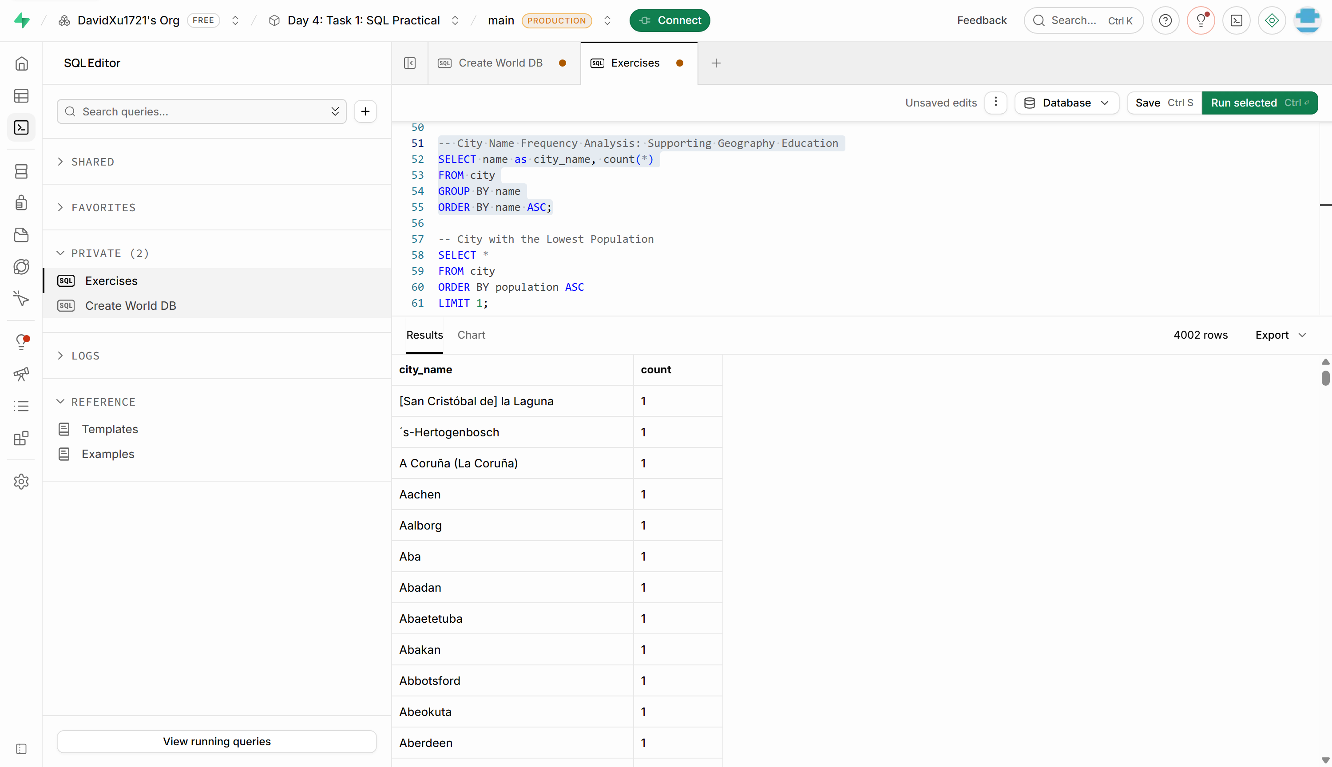

- City with the Lowest Population: Scenario: A census bureau is conducting an analysis of urban population distribution. You're tasked with identifying the city with the lowest population from the database to provide a comprehensive overview of demographic trends.
-- City with the Lowest Population
SELECT *
FROM city
ORDER BY population ASC
LIMIT 1;
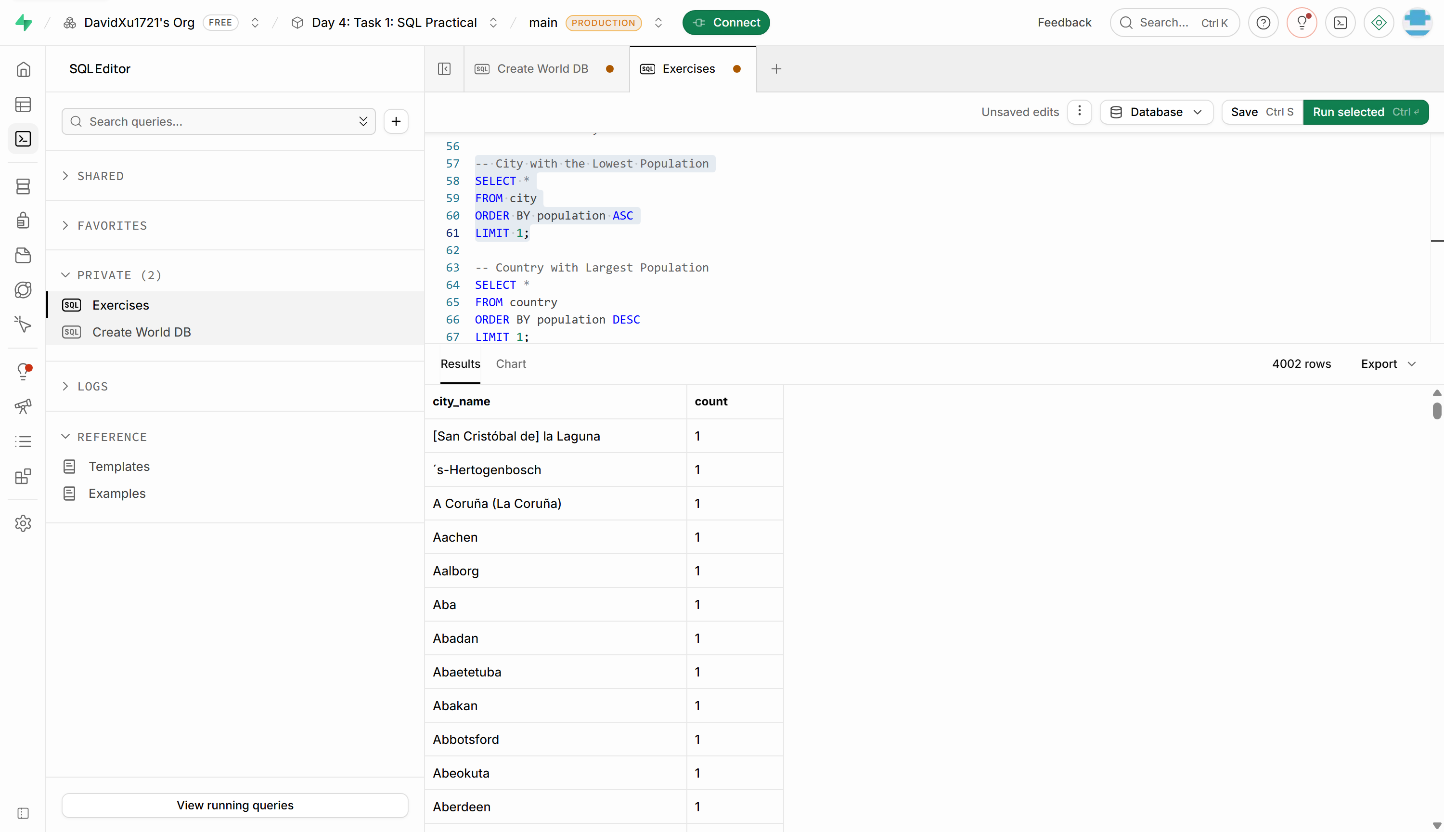

- Country with Largest Population: Scenario: A global economic research institute requires data on countries with the largest populations for a comprehensive analysis. You're tasked with identifying the country with the highest population from the database to provide valuable insights into demographic trends.
-- Country with Largest Population
SELECT *
FROM country
ORDER BY population DESC
LIMIT 1;
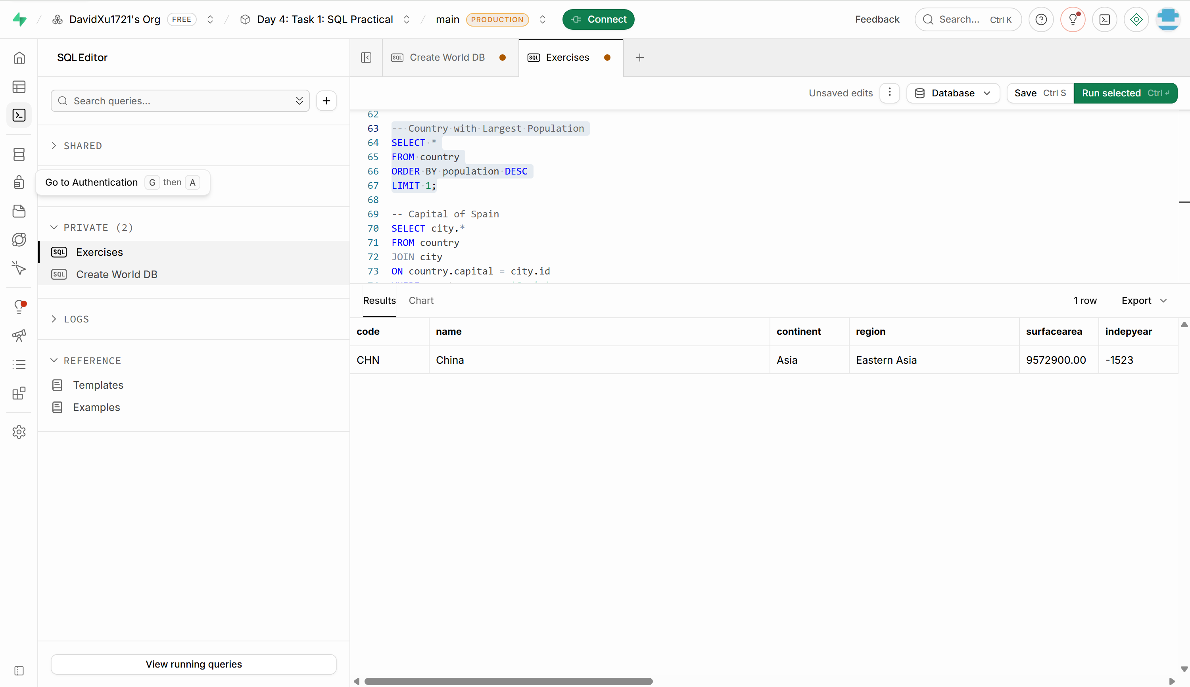

- Capital of Spain: Scenario: A travel agency is organising tours across Europe and needs accurate information on capital cities. You're tasked with identifying the capital of Spain from the database to ensure itinerary accuracy and provide travellers with essential destination information.
-- Capital of Spain
SELECT city.*
FROM country
JOIN city
ON country.capital = city.id
WHERE country.name = 'Spain';
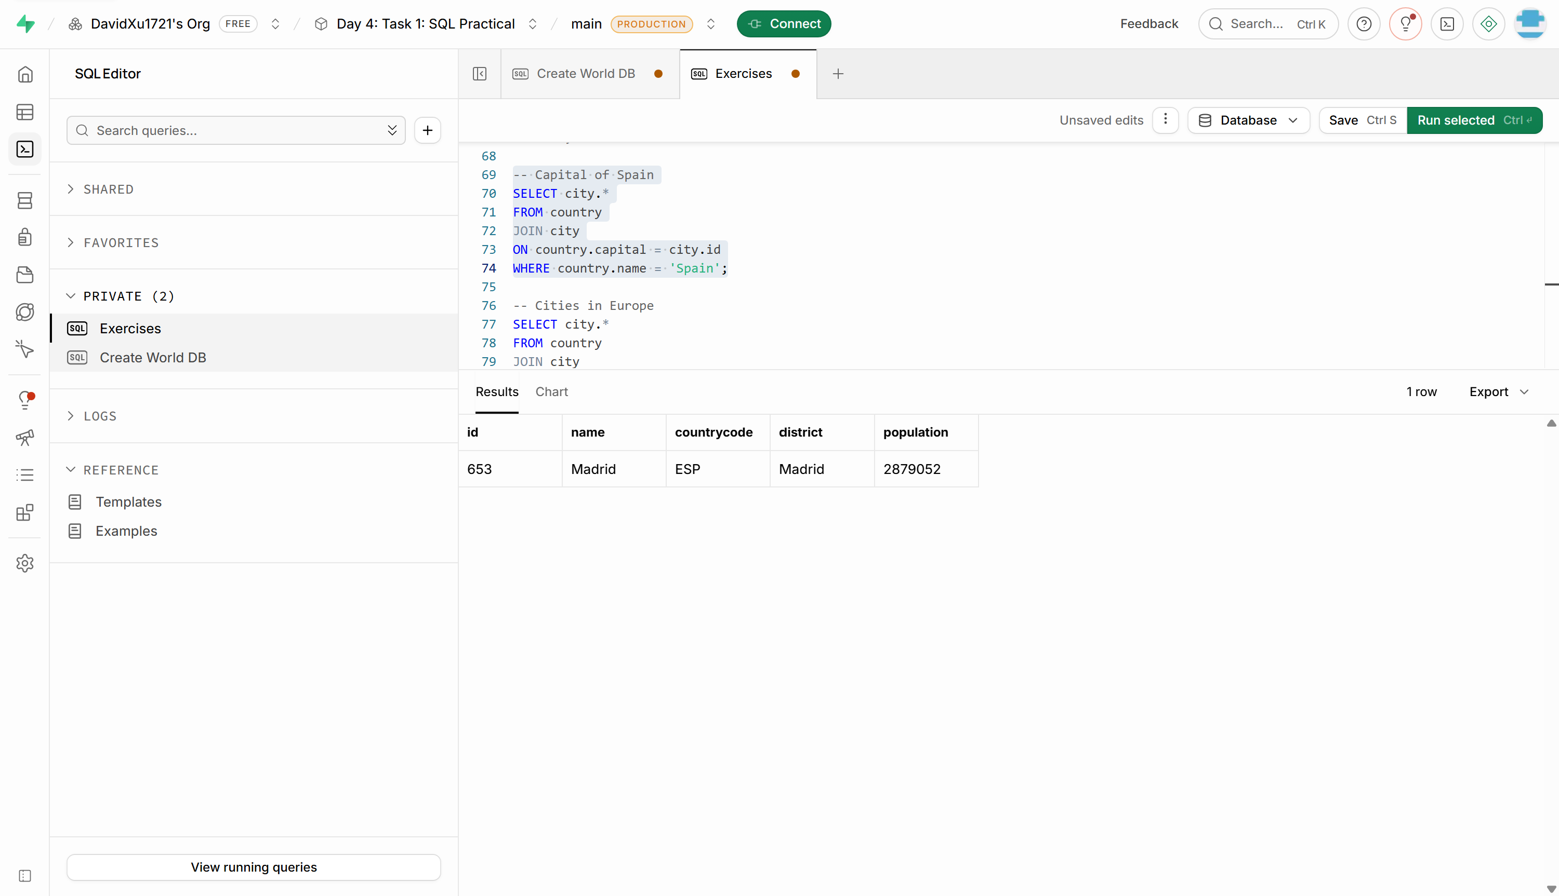

- Cities in Europe: Scenario: A European cultural exchange program is seeking to connect students with cities across the continent. You're tasked with compiling a list of cities located in Europe from the database to facilitate program planning and student engagement.
-- Cities in Europe
SELECT city.*
FROM country
JOIN city
ON country.code = city.countrycode
WHERE country.continent = 'Europe';
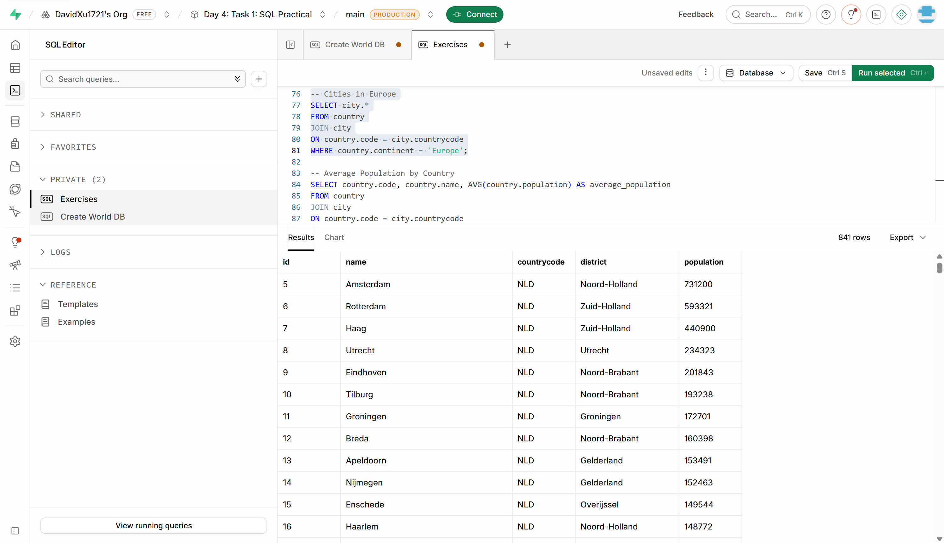

- Average Population by Country: Scenario: A demographic research team is conducting a comparative analysis of population distributions across countries. You're tasked with calculating the average population for each country from the database to provide valuable insights into global population trends.
-- Average Population by Country
SELECT country.code, country.name, AVG(city.population) AS average_population
FROM country
JOIN city
ON country.code = city.countrycode
GROUP BY country.code;
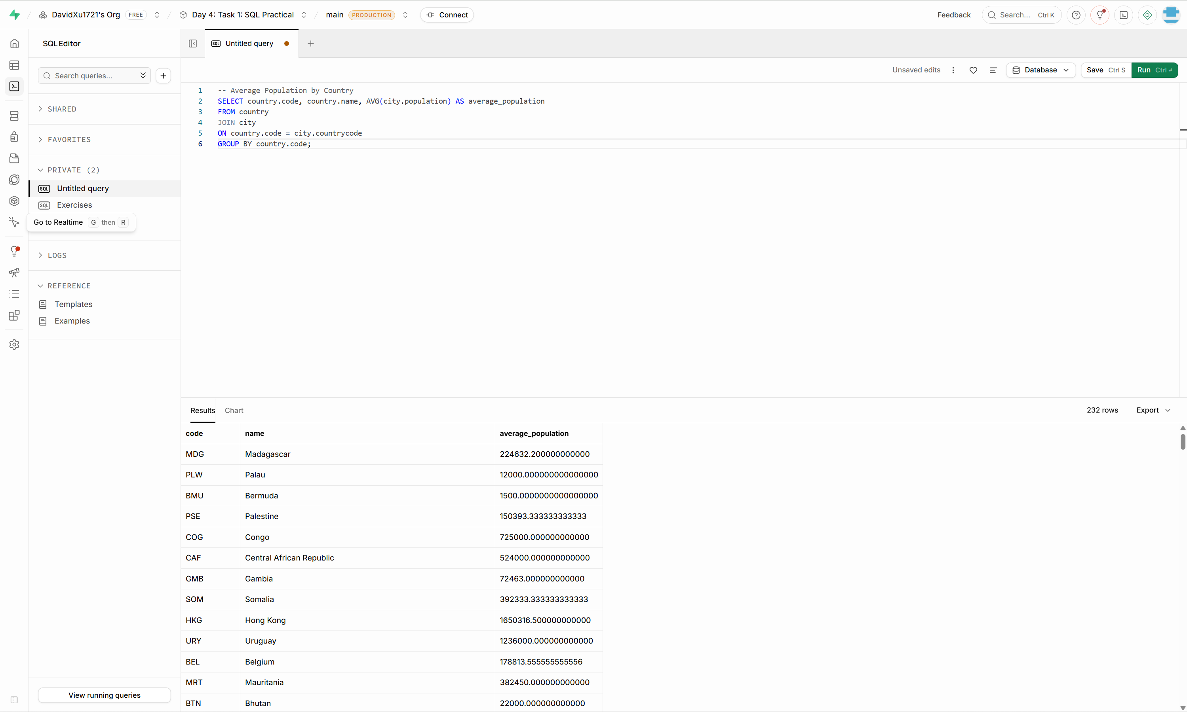

- Capital Cities Population Comparison: Scenario: A statistical analysis firm is examining population distributions between capital cities worldwide. You're tasked with comparing the populations of capital cities from different countries to identify trends and patterns in urban demographics.
-- Capital Cities Population Comparison
SELECT city.name, city.population, country.name AS country_name
FROM country
JOIN city
ON country.capital = city.id;
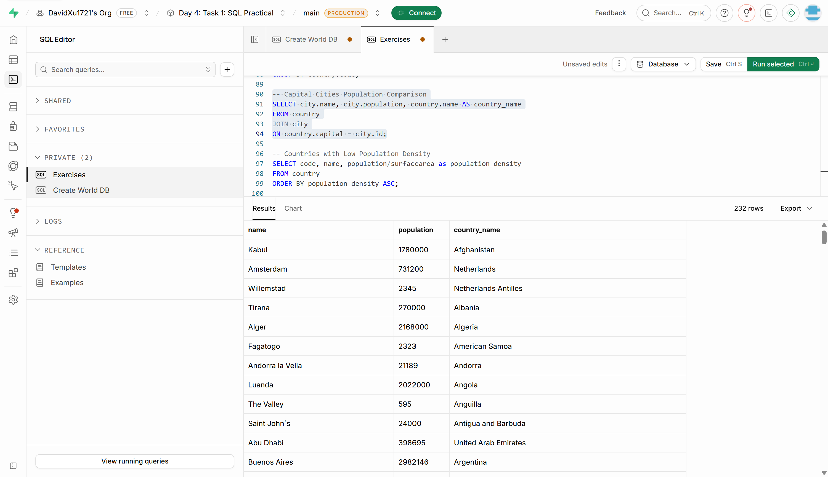

- Countries with Low Population Density: Scenario: An agricultural research institute is studying countries with low population densities for potential agricultural development projects. You're tasked with identifying countries with sparse populations from the database to support the institute's research efforts.
-- Countries with Low Population Density
SELECT code, name, population/surfacearea as population_density
FROM country
ORDER BY population_density ASC;
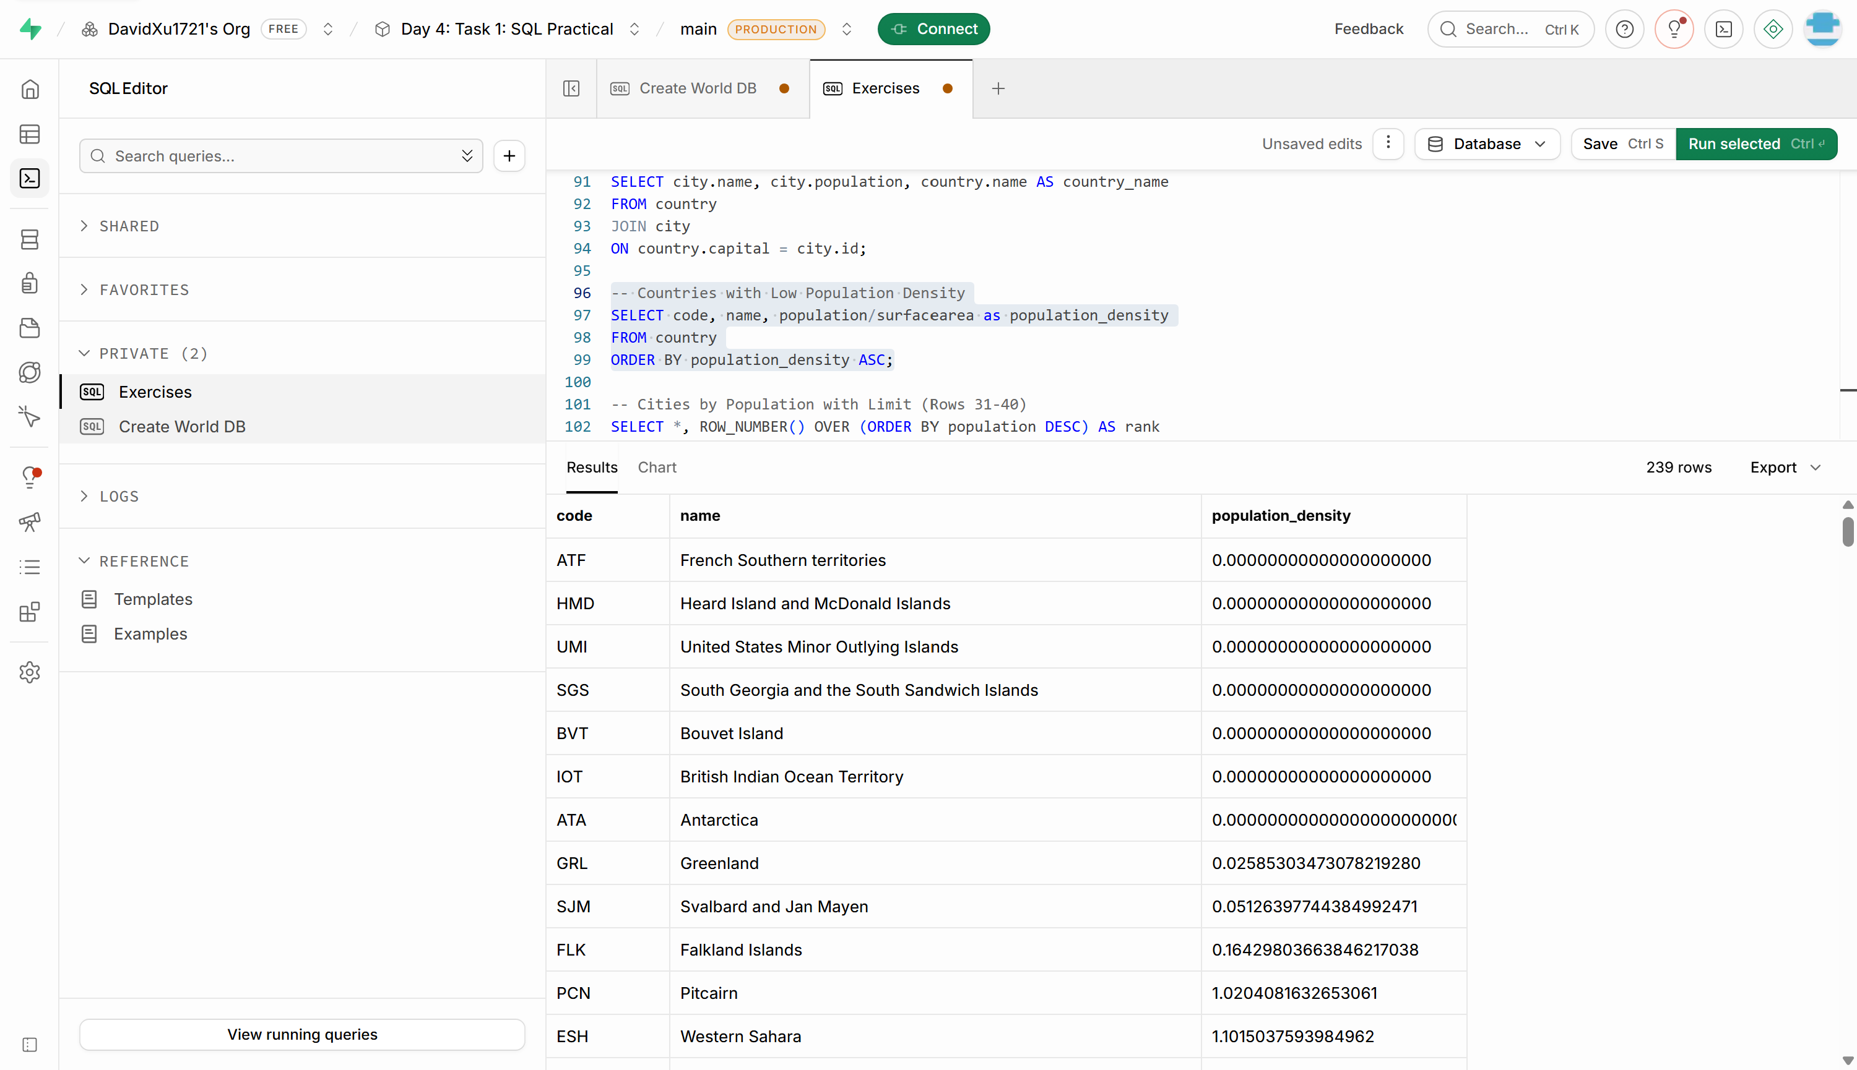

- Display Columns with Limit (Rows 31-40): Scenario: A market research firm requires detailed information on cities beyond the top rankings for a comprehensive analysis. You're tasked with providing data on cities ranked between 31st and 40th by population to ensure a thorough understanding of urban demographics.
-- Cities by Population with Limit (Rows 31-40)
SELECT *
FROM (
SELECT *,
ROW_NUMBER() OVER (ORDER BY population DESC) AS rank
FROM city
) AS ranked_cities
WHERE rank BETWEEN 31 AND 40;

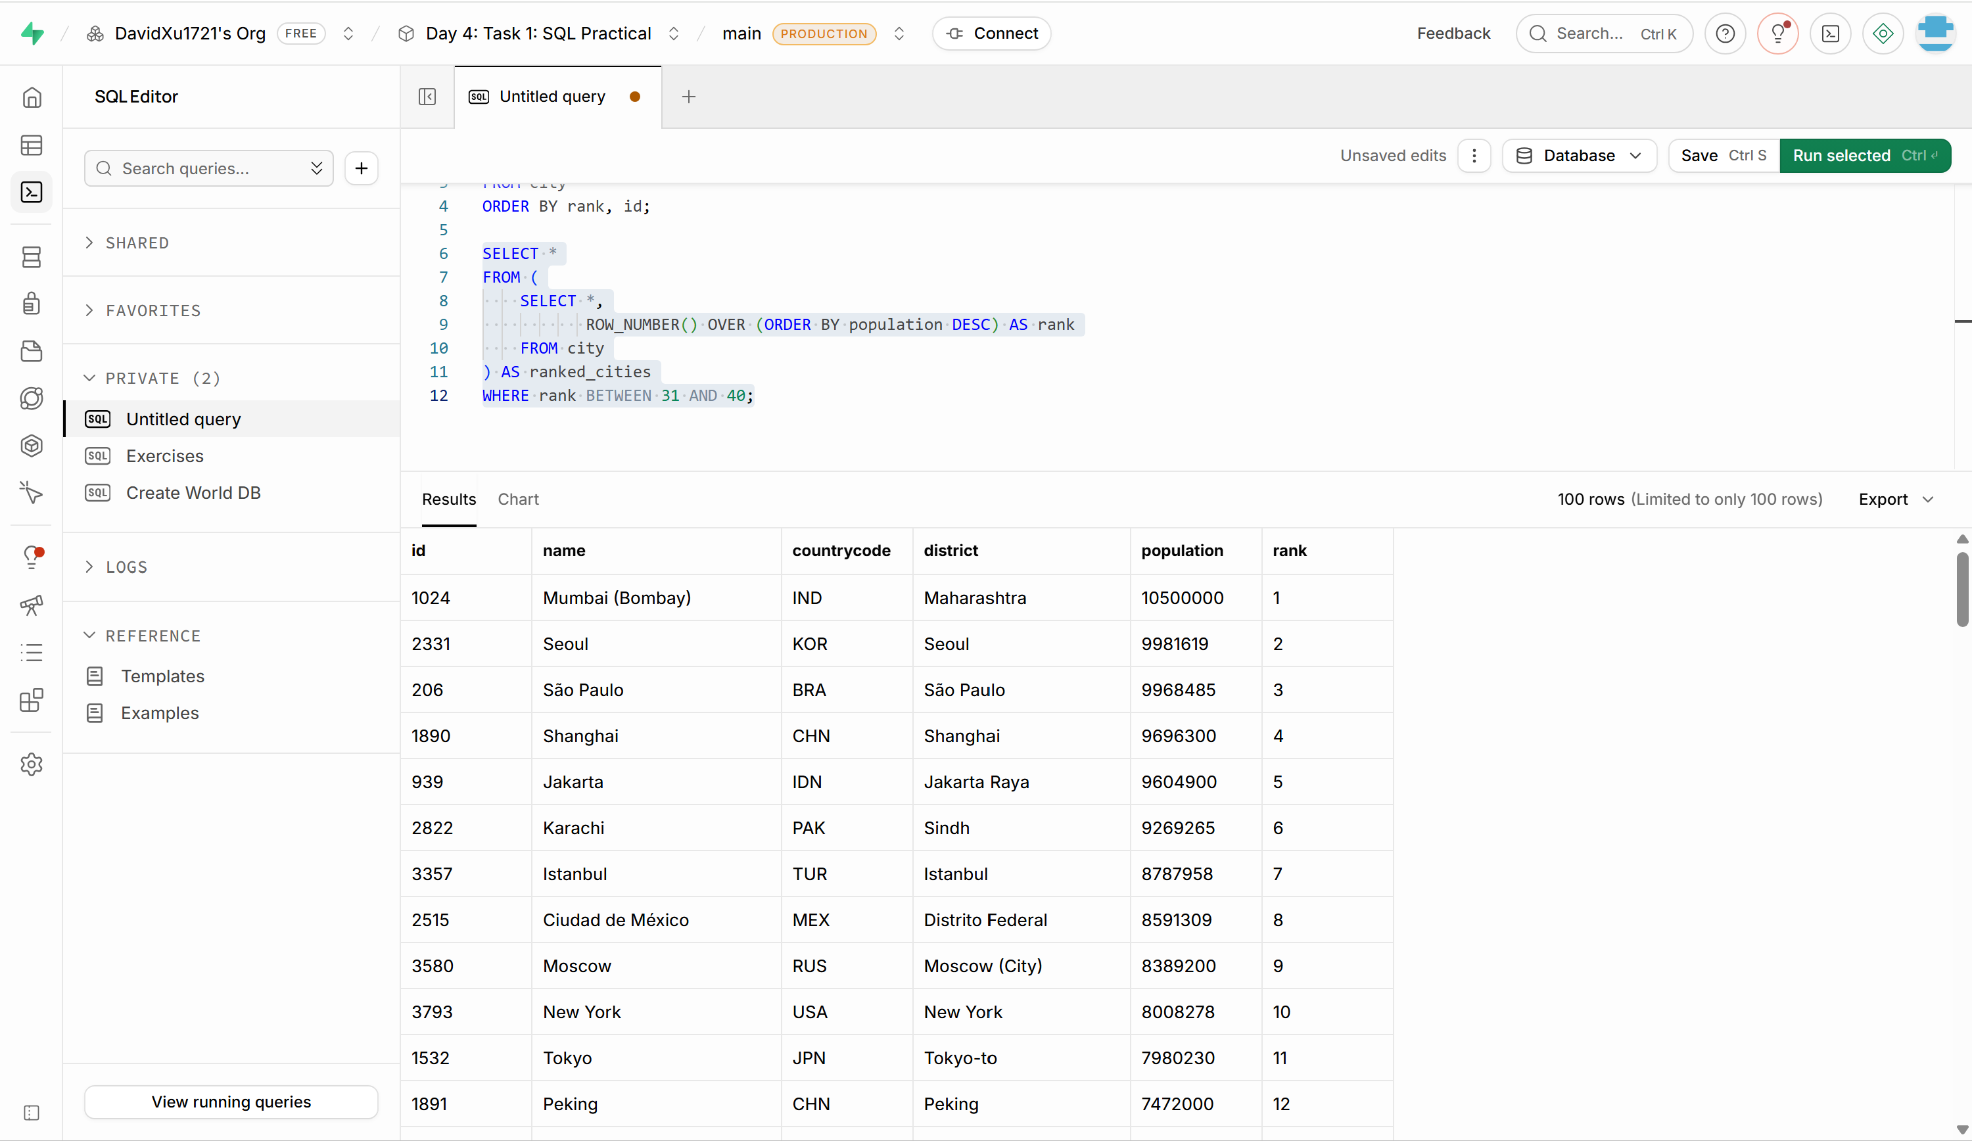

Additional Resources
- DataCamp Recommended Courses
- Introduction to SQL - DataCamp Learn
- Intermediate SQL - DataCamp Learn
- Joining Data in SQL - DataCamp Learn

- SQLBolt - Learn SQL - Introduction to SQL : Welcome to SQLBolt, a series of interactive lessons and exercises designed to help you quickly learn SQL right in your browser.

- MySQL Tutorial: Tutorial website.

- MySQL Basics Tutorial Series - YouTube: MySQL Basics Tutorial Series

- Hackerrank Challenges: How to use hackerrank challanges.odt

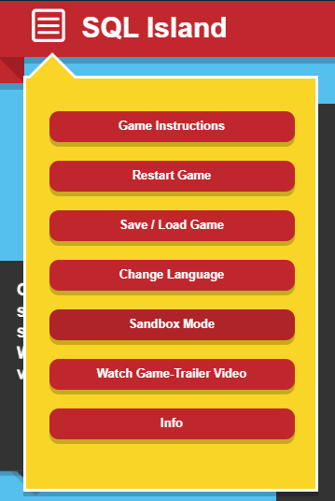
- SQL Island: After the survived plane crash, you will be stuck on SQL Island for the time being. By making progress in the game, you will find a way to escape from this island.
Change Language to English.

Course Notes

It is recommended to take notes from the course, use the space below to do so, or use the revision guide shared with the class:

We have included a range of additional links to further resources and information that you may find useful, these can be found within your revision guide.

END OF WORKBOOK

Please check through your work thoroughly before submitting and update the table of contents if required.

Please hand in your workbook in MS Assignment page.

